VIETNAM-KOREA UNIVERSITY OF INFORMATION AND COMMUNICATION TECHNOLOGY
Faculty of Computer Science



GRADUATION THESIS
RESEARCH AND APPLY AI CHATBOT TECHNOLOGY IN TOUR BOOKING MANAGEMENT

Student: Pham Duc Trung - 20IT610
Huynh Quang Huy - 20IT611
Class: 20SE2
Supervisor: DUONG THI MAI NGA

VIETNAM-KOREA UNIVERSITY OF INFORMATION AND COMMUNICATION TECHNOLOGY
Faculty of Computer Science



GRADUATION THESIS
RESEARCH AND APPLY AI CHATBOT TECHNOLOGY IN TOUR BOOKING MANAGEMENT

Student: Pham Duc Trung - 20IT610
Huynh Quang Huy - 20IT611
Class: 20SE2
Supervisor: DUONG THI MAI NGA

SUPERVISOR’S COMMENT

.................................................................................................................................
.................................................................................................................................
.................................................................................................................................
.................................................................................................................................
.................................................................................................................................
.................................................................................................................................
.................................................................................................................................
.................................................................................................................................
.................................................................................................................................
.................................................................................................................................

ACKNOWLEDGEMENTS

I would like to extend my deepest gratitude to the individuals and organizations that supported me throughout the process of completing this thesis:
- To my supervisor, Ms. Dương Thị Mai Nga for their invaluable guidance, encouragement, and feedback throughout my research journey. Your expertise and insights have been instrumental in shaping this work.
- To the Vietnam-Korea University of Information and Communication Technology, for providing the resources and facilities required to conduct my study.
- To my classmates and colleagues, for their constructive discussions and moral support, which motivated me to keep progressing.
- To my family and friends, for their unwavering patience and support during this demanding period.

STATEMENT OF AUTHORSHIP

................................................................................................................................
................................................................................................................................
................................................................................................................................
................................................................................................................................
................................................................................................................................
................................................................................................................................
................................................................................................................................
Danang, November 21th, 2024

HUYNH QUANG HUY PHAM DUC TRUNG

TABLE OF CONTENTS
SUPERVISOR’S COMMENT i
ACKNOWLEDGEMENTS ii
STATEMENT OF AUTHORSHIP iii
TABLE OF CONTENTS iv
ABBREVIATIONS v
LIST OF FIGURES vi
LIST OF TABLES viii
INTRODUCTION 1
- The Importance of AI Technology in Tour Booking Management 1
- The Role of Chatbots in Enhancing User Experience 1
- Research and Application Objectives 1
- Structure of the thesis 1
CHAPTER 1.OVERVIEW OF THE TOPIC 2
CHAPTER 2.SYSTEM ANALYSIS AND DESIGN 6
CHAPTER 3.TECHNOLOGY SOLUTIONS 34
  - Technologies Related to Chatbots 34
  - Technologies Related to PHP and Laravel 36
  - Summary of Technology Selection Reasons 37
CHAPTER 4.IMPLEMENTATION RESULTS 38
EVALUATION AND CONCLUSION 54
REFERENCES 56
APPENDIX 57

ABBREVIATIONS

ABBREVIATIONS | MEANING
WWW | World Wide Web
HTML | HyperText Markup Language
SEO | Search Engine Optimization
API | Application programming interface
HTTP | HyperText Transfer Protocol
SQL | Structured Query Language

LIST OF FIGURES
Figure 2.1: Use Case Diagram 8
Figure 2.2: Customer Use Case Diagram 9
Figure 2.3: Login Use Case Diagram 9
Figure 2.4: Sign up use case diagram 10
Figure 2.5: Search Use Case Diagram 11
Figure 2.6: Use Case Diagram Comments 11
Figure 2.7: Use Case Diagram Book tour 12
Figure 2.8: Use Case Diagram Tour Management 13
Figure 2.9: Use Case Diagram Tour Location Management 15
Figure 2.10: Use Case Diagram Tour Status Management 16
Figure 2.11: Use Case Diagram User Management 17
Figure 2.12: Tour search operation specification 19
Figure 2.13: Add tour activity specification 20
Figure 2.14: Edit tour operation specification 21
Figure 2.15: Delete tour operation specification 22
Figure 2.16: Tour booking activity specification 23
Figure 2.17: Relational schema diagram 33
Figure 4.1: Main interface screen 39
Figure 4.2: Home screen showing featured Tours 40
Figure 4.3: Home screen showing Travel News 40
Figure 4.4: Home screen of contact us section 41
Figure 4.5: Customer registration screen 42
Figure 4.6: Tour Program Details Interface 42
Figure 4.7: Tour schedule interface screen, Tour introduction 43
Figure 4.8: Tour Comments Interface 43
Figure 4.9: Tour booking interface screen 44
Figure 4.10: Hotel Interface 44

Figure 4.11: Admin Dashboard Interface 45
Figure 4.12: New Category management interface screen 45
Figure 4.13: Category list management interface screen 46
Figure 4.14: Management interface screen to create new News article 46
Figure 4.15: News article management interface screen 47
Figure 4.16: Tour Location Management Interface 47
Figure 4.17: Tour Location management interface screen 48
Figure 4.18: Tour Program Management Interface 48
Figure 4.19: Tour Program management screen 49
Figure 4.20: Tour booking management interface screen 49
Figure 4.21: Hotel management interface screen 50
Figure 4.22: Hotel management interface screen 50
Figure 4.23: Comment management interface screen 51
Figure 4.24: Account Role Management Interface Screen 51
Figure 4.25: User account management interface screen 52
Figure 4.26: User account management interface screen 52
Figure 4.27: Chatbot AI 53
Figure 4.27: Chatbot AI 53

LIST OF TABLES
Table 2.1: System actors table 6
Table 2.2: List of symbols 8
Table 2.3: Table describing the main functions of the system 25
Table 2.4: List of main object classes and relationships 25
Table 2.5: Detailed description table of Tour Booking classes 26
Table 2.6: Detailed description table of the classes of Tour Details 27
Table 2.7: Table detailing the classes of the Catalog 28
Table 2.8: Detailed description of News classes 28
Table 2.9: Table detailing the Hotel classes 29
Table 2.10: Table detailing the classes of Comments 30
Table 2.11: Table detailing the layers of the Location 30
Table 2.12: Detailed description of Contact classes 30
Table 2.13: Detailed description table of User classes 31
Table 2.14: Detailed description table of the classes of the Authorization Group 31
Table 2.15: Detailed description of the layers of Decentralization 32
Table 2.16: Detailed description table of the layers of Role Delegation 32
Table 2.17: Detailed description table of Role classes 32
Table 2.18: Detailed description table of User Role classes 32
Table 2.19: Table detailing the layers of Password Reset 33

INTRODUCTION

The Importance of AI Technology in Tour Booking Management
With the rapid growth of the tourism industry and the significant increase in online tour booking demands, integrating advanced technologies into tour booking management has become essential. Artificial Intelligence (AI) technology leads the way in providing intelligent solutions that optimize processes and enhance customer experience. AI-powered chatbots emerge as a powerful tool, enabling automation, consultation, and interaction with customers efficiently, seamlessly, and around the clock.

The Role of Chatbots in Enhancing User Experience

Chatbots not only reduce the workload for staff but also act as a direct communication bridge with customers, operating 24/7. In the tourism sector, chatbots can assist users in searching for tour information, checking itineraries, booking reservations, and addressing inquiries. This not only helps tourism businesses increase operational efficiency but also significantly enhances customer satisfaction.

Research and Application Objectives
This study focuses on researching and applying AI chatbot technology to address issues in tour booking management, with the following key objectives:
  - To study the current chatbot technologies and evaluate their applicability in the tourism sector.
  - To analyze and design a chatbot system tailored to the requirements of tour booking management.
  - To develop and deploy a chatbot integrated into the tour booking management system, aiming to optimize processes and improve user experience.

Structure of the thesis
After the Introduction, the thesis is structured in four chapters:
Chapter 1,OVERVIEW OF THE TOPIC. In this chapter, the thesis presents Overview of the topic.
Chapter 2,SYSTEM ANALYSIS AND DESIGN. This chapter includes System design analysis.
Chapter 3,TECHNOLOGY SOLUTIONS. This chapter proposes Technology solutions
Chapter 4,INTERFACE DESIGN. This chapter presents Project implementation Finally, there are Conclusions, Suggestions, References related to the topic.

CHAPTER 1. OVERVIEW OF THE TOPIC

Reason for choosing the topic
Nowadays, as the pace of life becomes increasingly hectic and busy, people have less time for leisure activities. Consequently, the tourism industry has emerged to meet this growing demand. This demand continues to rise as the quality of human life improves. Furthermore, tourism serves as a form of cultural and national promotion, allowing countries to showcase their unique landscapes and people to the global community. To develop the tourism industry, it is essential to promote it widely to visitors around the world. One of the most effective means of promoting tourism today is through the highly advanced Internet. Businesses in the tourism sector recognize its immense potential for supporting their operations.
In Vietnam, many industries are leveraging this opportunity to attract customers, enhance business performance, and achieve notable success. E-commerce is reshaping how businesses operate in this highly competitive and integrated era, and the tourism industry is no exception. Recognizing these challenges and opportunities, we, in collaboration with Ms. Dương Thị Mai Nga, have chosen the topic “Research and apply AI Chatbot technology in tour booking management” as our graduation project. This initiative aims to apply the knowledge we have acquired during our studies and implement it in practice. Our goal is to promote Vietnam's beautiful landscapes, as well as those globally, while providing companies with a platform to showcase their tour packages, enabling customers to select the most ideal destinations for relaxation and leisure after busy work schedules.

General status
Currently, unlike countries with advanced and prevalent IT systems, Vietnam largely relies on static websites. These have fixed structures and content that rarely change, serving primarily as a medium to introduce companies and their services.
In addition to this, there are also dynamic websites with varied designs, layouts, and management systems, such as those of companies like Vietnam Media Travel Corporation and Viet Travel. However, a significant observation is that most websites are initially designed by professional website design companies, which is reasonable. The initial investment, though relatively high for dynamic websites, ensures a professionally designed and stable website. Yet, for a website to operate effectively, the active involvement of its owner or the company's management team is crucial.
In Vietnam, the role of website administrators is often undervalued. Most company website administrators manage this task only after completing other responsibilities. Updating website content is frequently overlooked, resulting in monotonous sites that fail to retain visitor interest over time.

Companies owning these websites typically have dedicated teams to manage their website's information, ensuring prompt and efficient customer service via the Internet. Only by doing so can the full value of the website and its potential online customer base be realized.
Therefore, in our opinion, companies planning to build their own websites must prioritize the role of IT and their potential customer base on the Internet. A strategic plan should include dedicated website administrators to ensure the company's site remains fresh, engaging, and attractive to visitors, ultimately driving more customers to both the website and the business.

Topic Overview
The Research And Apply Ai Chatbot Technology In Tour Booking Management is designed to assist travel companies in showcasing their tour packages to customers, particularly those unable to build or purchase a website for business purposes. Additionally, this tour booking website serves as a platform to introduce travel destinations and provide helpful travel tips or guides. Acting as a bridge between travel agencies and customers, the website aims to facilitate the process of presenting travel packages to interested customers. It also helps users efficiently and quickly select suitable destinations without spending excessive time searching.

Research topic direction
In theory
  - Research theories about websites and study web development languages that have been used both domestically and globally. Based on this research, select an appropriate language for building websites for booking tourism tours.
  - Examine the operations of a travel company to establish requirements and identify necessary functionalities.
  - Propose several development directions for the project.
Topic builder tool
  - Tools for Researching Theoretical Foundations: Reference materials such as programming language books, technologies of required frameworks like Laravel, textbooks, websites, etc.
  - Tools for Software Design: Visual Studio Code, Sublime Text, SQL Server 2019, StarUML, etc,…

Expected results
We strive to develop a comprehensive and highly optimized website to enhance efficiency and professionalism in business operations, while effectively promoting the image of travel companies:
  - About referral advertising: Update information about travel companies, tour images, and related details both domestically and internationally, enabling individuals or organizations to view them directly through our website.

+ The homepage includes a brief introduction to travel companies and banners for advertisements, providing unique and attractive travel information, as well as tours with promotions for the month.
+ In addition, our website also introduces scenic spots, local activities, and cultural practices of different regions across the country, as well as travel information about restaurants, hotels, and other establishments at each location. This information is provided and regularly updated by the website administrator. If there is any feedback from readers, the administrator can quickly add, edit, or delete content as needed.
  - About website interface: The website also includes a sitemap, search functionality, and customer support features, helping users quickly find the information they need.
  - About Tour information: The website provides detailed itineraries, images, and articles about specific travel tours, as well as standout cultural products unique to each region. It also includes a pricing table for services ranging from individual offerings to all-inclusive packages.
  - About the customer: Customers can search for and view travel tour information on the website. If they wish to book a tour, they must register an account and provide accurate personal information so that the company can contact them for confirmation when they wish to make a booking.
  - About Contact: The website serves as a bridge, supporting communication between customers and the company, handling inquiries and facilitating feedback between both parties.

PHP Language
  - Introduction to PHP language
PHP, which stands for "Hypertext Preprocessor," is a server-side scripting language used to generate HTML code on the client side. PHP has gone through numerous versions and has been optimized for web applications. With its clear syntax, fast execution, and ease of learning, PHP has become a very popular and widely used programming language for web development.
PHP runs on a web server environment and stores data through a database management system. Therefore, PHP is commonly used with Apache, MySQL, and the Linux operating system, forming the LAMP stack (Linux, Apache, MySQL, PHP). This combination is widely used for developing and hosting dynamic websites and web applications.
  - Apache is a web server software responsible for receiving requests from users' browsers, then passing them to PHP for processing, and finally sending the processed results back to the browser. It acts as an intermediary that handles incoming HTTP requests and serves static content or routes dynamic content to the appropriate processing engine, like PHP.

  - MySQL, like other database management systems (DBMS) such as PostgreSQL, Oracle, and SQL Server, serves as a platform for storing and querying data. It is used to manage structured data through tables and allows for efficient retrieval, insertion, and manipulation of data via SQL queries. MySQL is widely used in web applications for handling backend data storage and operations.
  - Linux is an open-source operating system widely used for web servers. The most commonly used distributions for web hosting include Red Hat Enterprise Linux (RHEL), Ubuntu, and CentOS. Linux is preferred for its stability, security, and flexibility, making it an ideal choice for running web servers and supporting web applications…

CHAPTER 2. SYSTEM ANALYSIS AND DESIGN

Here is the Use Case diagram and its detailed specification, analyzed based on the functions presented above

System actors

STT | Actors | Meaning and mission of Actor
1 |  | Customers visit the website to view its content.  They can search, view, select, and book tours. Customers can also read articles about promotions and travel tours.  Additionally, customers are provided with  online support, can leave comments about tours, and provide feedback on the website.
2 |  | The admin actor is the main role of the website system, responsible for operating, managing, and monitoring all activities of the system.  The admin can perform all functions available in the system's administration, such as: logging in, managing posts, managing tours, managing categories, managing  customers, and conducting searches.…
3 |  | The staff actor is a sub-role in the website system, responsible for activities related to the management of comments, categories and information related to the tour.  The staff can perform all available functions that have been decentralized in the system, such as: manage comments, manage category, customer consultation, update tour booking form, update tour information,  manager post, etc.
Table 2.1: System actors table

List of symbols

Model element | Symbol | Meaning
Use Case Diagram
Actor |  | A person/group of people, a device, or a system that interacts with or manipulates the program
Use case | 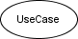 | A representation of a specific function of the system.
Relationship between use cases |  | This use case reuses the functionality of another use  case.
 | 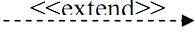 | This use case extends from another use case by adding  specific functionality.
 |  | This use case inherits  functionalities from another use case.
Activity Diagram
Activity | 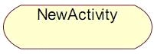 | An activity description includes the activity name  and its specification.
Initial state |  | Marks the start of the activity  flow.
End state |  | Marks the end of the activity flow.
Horizontal sync bar |  | Description of horizontal sync bar
Forward |  | Indicates the direction of the flow from one activity to another.

Decision |  | Describes a conditional selection
Flows | Separates different object classes in an activity  diagram. | Separated by a vertical line from top to bottom in the  diagram.
Table 2.2: List of symbols

Use Case Diagram
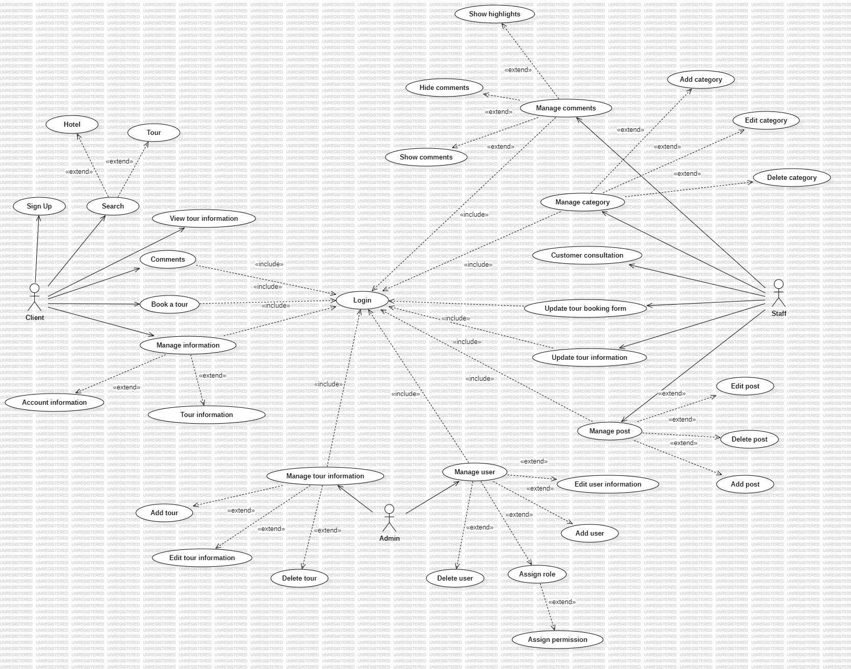
Main Use Case Diagram:
Figure 2.1: Use Case Diagram

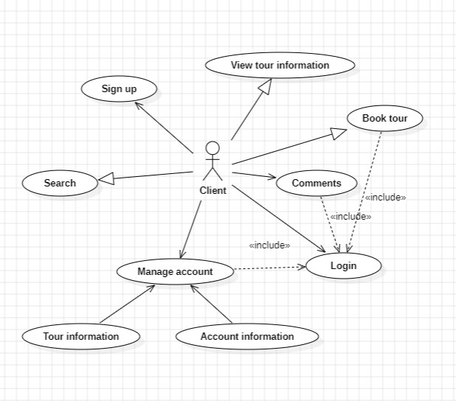
Use Case Diagram - Customer
Figure 2.2: Customer Use Case Diagram

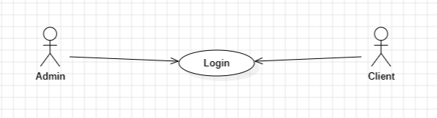
Use Case Diagram - Login
Figure 2.3: Login Use Case Diagram

Actor: Admin, Member Customer

General Description:
- Admin accesses the admin panel to manage their system.
- Member customers log into the system.
Input Condition: The use case begins when the user wants to log into the system.

Main Event Flow:
- The system prompts the user to enter a username and password.

- The user enters the username and password.
- The system checks the entered username and password. If correct, access to the system is granted.

Alternative Event Flow:
- If the username or password is incorrect in the main scenario, the system displays an error.
- The user can either re-enter the credentials or cancel the login attempt, in which case the use case ends.

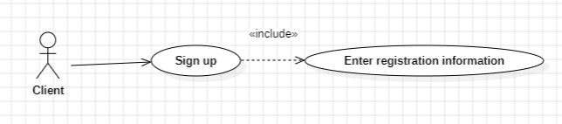
Use Case Diagram Sign Up
Figure 2.4: Sign up use case diagram

Actor: Customer
General Description: Allows the customer to register as a member of the system.
Input Condition: The use case begins when the customer accesses the system and chooses to register as a member.

Main Event Flow:
- The customer selects the "Register as Member" option.
- The membership registration form is displayed.
- The customer enters the required personal information into the registration
form.
- The customer clicks the "Register" button.
- The system displays the result of the personal information input process. If
the information is correct, the system updates the customer’s information into the member list.
- The use case ends when the customer selects "Exit."

Alternative Event Flow:
If the entered information is incorrect:
- The system notifies the customer that the information is incorrect.
- The system asks the customer to review the information.
- If the customer agrees, they can re-enter the information. If not, the use case
ends.

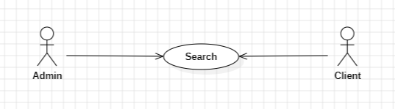
Use Case Diagram - Search
Figure 2.5: Search Use Case Diagram

Actor: Customer, Administrator
General Description: Displays search results for the requested tour program information.
Input Condition: The use case starts when the user accesses the website and enters the search query. The system will automatically perform the search request.

Main Event Flow:
- The use case starts when the user accesses the website and selects the search option. Then, the user enters the search keyword, and the system checks if the keyword is valid:
- The system begins displaying information about products or articles found based on the search query.
- The user can choose to view the information or select "Exit," in which case the use case ends.

Alternative Event Flow:
If the keyword is invalid:
- The user can re-enter the keyword or cancel the search, in which case the use case ends.

Use Case Diagram - Comments
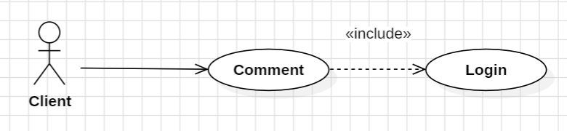
Figure 2.6: Use Case Diagram Comments

Actor: Customer
General Description: The customer must log in to the website. If the customer has feedback about a product, they will write it in the comment section.
Input Condition: The use case begins when the customer writes a comment in the comment section.

Main Event Flow:
- The customer selects the "Comment" option. The system will display the comment section on the screen.
- After writing the comment, the customer submits it to the system.
- The system automatically saves the comment for review. If there are any questions, the system will respond to the customer.

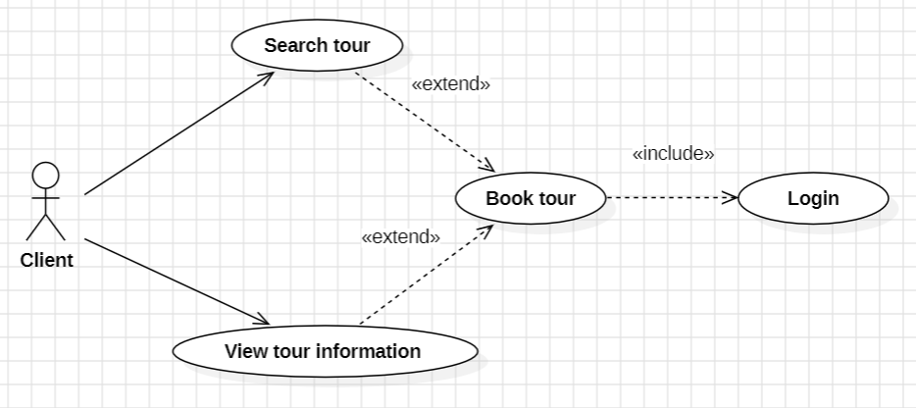
Use Case Diagram - Book tour
Figure 2.7: Use Case Diagram Book tour

Actor: Customer
General Description: This use case allows the customer to select a tour.
Input Condition: The use case starts when the product (tour) to be selected is displayed on the system.

Main Event Flow:
- The customer selects the "Tour" option.
- The system displays the available tours that were selected.
- The customer views the information about the tour they want to book.
- If the system displays the desired tour, the customer selects the specific tour to book.
- The use case ends.

Alternative Event Flow:
If the customer selects to book a tour in a different section:

- The system will display the available tours in that section.

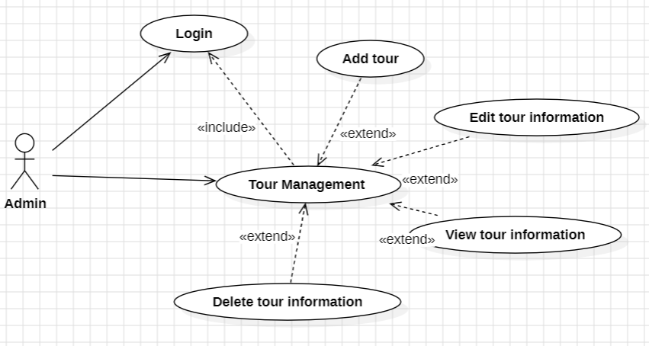
Use Case Diagram - Tour Management
Figure 2.8: Use Case Diagram Tour Management

Actor: Administrator
General Description: The administrator needs to quickly access tour information to update the website.
Input Condition: The use case starts when the user successfully logs into the system.

Main Event Flow:
- The use case starts when the user logs in and enters their password.
- The system checks the username and password. If correct, it displays a list of posts. If incorrect, no further action is taken.
- The system prompts the user to choose an action: add, edit, delete, or exit.
- If "Add new tour program" is selected, the sub-event for adding a new tour is executed.
- If "Edit tour information" is selected, the sub-event for editing the tour is executed.
- If "Delete/Close tour program" is selected, the sub-event for deleting a tour is executed.
- If "Exit" is selected, the use case ends.

Sub-events:
- Add new tour program:

  - The system prompts the administrator to enter details for the new tour

program.
  - After completing the details, the administrator selects "Add," and the system checks the validity of the input.
  - The tour program is added to the system.
  - The list of tour programs is updated and displayed.

Edit tour program:

  - The system retrieves and displays the details of the selected tour program.
  - The administrator edits the selected tour program.
  - After editing, the administrator selects "Update." The system checks the validity of the updated information.
  - The tour program is updated and displayed.

Delete tour program:

  - The system retrieves and displays the details of the selected tour program.
  - The administrator selects "Delete," and the system prompts for confirmation to delete the tour program.
  - If the administrator confirms, the tour program is completely removed from the system.

Alternative Event Flow:
- If the username or password is invalid, the system displays an error. The user can either re-enter the credentials or exit the use case.
- If the tour program is invalid or cannot be added or edited, the system displays an error. The user can either re-enter the information or exit the use case.
- If the tour program cannot be deleted, the system displays an error. The user can either try again or exit the use case..

Use Case Diagram - Tour Location Management
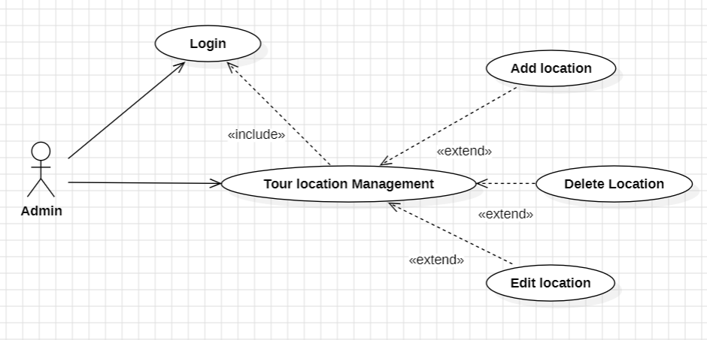
Figure 2.9: Use Case Diagram Tour Location Management

Actor: Administrator
General Description: The administrator needs to manage tour destinations, including actions such as adding, editing, and deleting destinations from the list of locations.
Input Condition: The use case starts when the administrator successfully logs into the system and selects the destination management option.

Main Event Flow:
- The use case begins when the administrator logs into the system.
- The system checks the password, and if correct, displays the list of destinations.
- The system displays options for the administrator: Add, Edit, Delete, or Exit.
  - If "Add new" is selected, the sub-event for "Add new destination" is executed.
  - If "Edit" is selected, the sub-event for "Edit destination information" is executed.
  - If "Delete" is selected, the sub-event for "Delete destination" is executed.
  - If "Exit" is selected, the use case ends.

Sub-events:
- Add new destination:

  - The system displays the form to enter destination details.
  - The administrator enters the destination information.
  - The administrator clicks the save button.

  - If the information is entered correctly, the process proceeds. If incorrect, the branch event A1 is triggered.
  - The destination information is saved.

Edit destination information:
  - The system displays the form to edit destination details.
  - The administrator enters the required changes.
  - The administrator clicks the save button.
  - If the information is successfully updated, the process proceeds. If there is an error, the branch event A1 is triggered.
  - The updated destination information is saved.

Delete destination:
  - The administrator selects the destination to delete.
  - The administrator clicks the delete button to remove the destination.
  - The system asks for confirmation to delete the destination. If the administrator agrees, the system confirms that the destination has been deleted. If the administrator disagrees, the list of destinations is displayed again.
  - The use case ends.

Branch Event A1:
- The system notifies the administrator of invalid data entry.
- The administrator re-enters the information and returns to step 3 of the main event flow.
Output Condition: The destination information is updated in the database, and the list of destinations is modified accordingly.

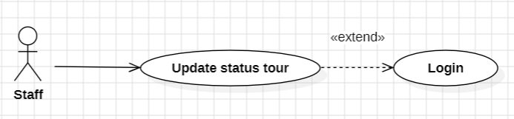
Use Case Diagram - Tour Status Management
Figure 2.10: Use Case Diagram Tour Status Management

Actor: Employee
General Description: The employee changes the status of the tour previously booked by customers.
Input Condition: The use case begins when the employee successfully logs into the system and selects the "Tour Booking List" option.

Main Event Flow:

- The use case starts when the employee logs into the system.
- The system verifies the password and displays the list of tour bookings.
- The system shows the current status of each tour booking. The employee can change the status of a booking to notify the customer whether their tour has been successfully confirmed or not.
  - If "Delete" is selected, the system asks the employee if they are sure they want to delete the booking.
  - If "Reception" is selected, the tour will be listed as pending, with no notification sent to the customer. (Reception is the default status.)
  - If "Confirmed" is selected, the system will mark the tour as confirmed, but no payment has been made, and no email is sent to the customer.
  - If "Paid" is selected, the system will send an email to the customer confirming the tour booking and payment has been successfully completed.
  - If "Completed" is selected, the system will send an email to the customer informing them that the tour has ended and apologizing for any inconvenience.
  - If "Cancelled" is selected, the system will send an email to the customer notifying them that the tour has been cancelled and apologizing for the cancellation.
Output Condition: The tour booking status is updated in the system, and the appropriate email notifications are sent to the customer based on the selected status.

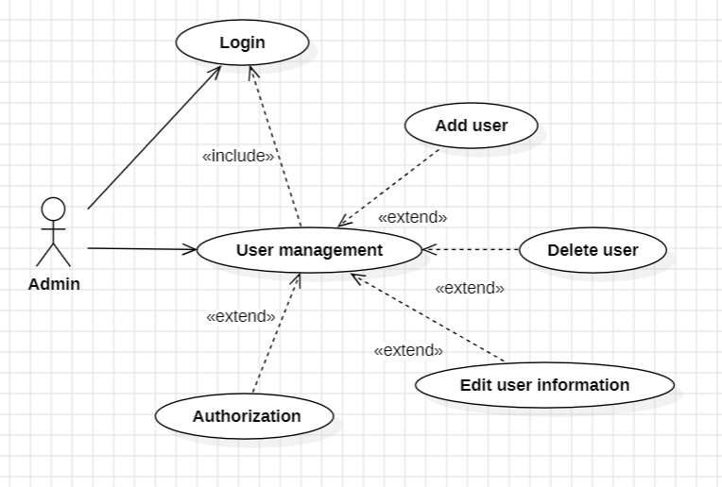
Use Case Diagram - User Management
Figure 2.11: Use Case Diagram User Management

Actor: Admin
General Description: The admin needs to manage the user list with actions such as

assigning roles, adding users, deleting users, and updating user information.
Input Condition: The use case begins when the admin successfully logs into the system and selects "Manage User List."

Main Event Flow:
- The use case starts when the admin logs into the system.
- The system verifies the password; if correct, it grants access to the system and the admin selects the "Manage User List" option.
- The system displays the following functions the admin can perform: Add, Delete, Edit, and Exit.
  - If "Add" is selected, the "Add New User" sub-event will be executed.
  - If "Delete" is selected, the "Delete User" sub-event will be executed.
  - If "Edit" is selected, the "Edit User Information" sub-event will be executed.
  - If "Exit" is selected, the use case ends.

Sub-event Flows: Add New User:
- The system displays a form to input user information.
- The admin enters the user details.
- The admin clicks the "Save" button to store the information.
- If the input is valid, the process continues; if invalid, it follows the alternative event flow (A1).
- The user information is saved.
- Note: When a user registers on the system, the system may automatically add the user to the list.

Edit User Information:
- The system displays a form to edit user details.
- The admin modifies the user information.
- The admin clicks the "Save" button to update the information.
- If the edit is successful, the process continues; if failed, it follows the alternative event flow (A1).
- The user information is updated.

Delete User:
- The admin selects the user to delete.
- The admin clicks the "Delete" button to remove the user.
- The system displays a confirmation message asking if the admin is sure about deleting the user.
- If the admin confirms, the system notifies that the user has been deleted. If the admin declines, the system returns to the user list.
- The use case ends.

Alternative Event Flow (A1):
- The system notifies the admin that the input data is invalid.
- The admin re-enters the correct information.
- The process returns to step 3 in the main event flow.
Output Condition: The user information is updated in the database.

Activity Diagram
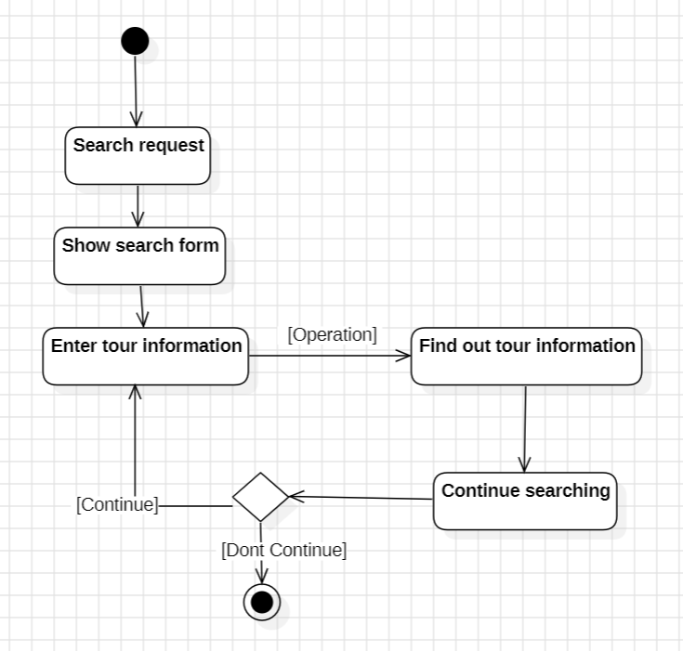
- Tour Search Operation Specification
Figure 2.12: Tour search operation specification

Search Process Specification for Tour Program
- The user requests to search for a tour program.
At this point, the actor interacts with the search function through the system's homepage interface.
- The system displays the search interface and prompts the actor to enter the information they want to search for.

- The search is executed. The system uses the actor's search keywords to query the database.
- The results are returned according to the actor's search request through the homepage interface.
- If the actor wants to continue searching for more information, they can enter new search terms as before, and the system will follow the same process.
- The search process concludes.

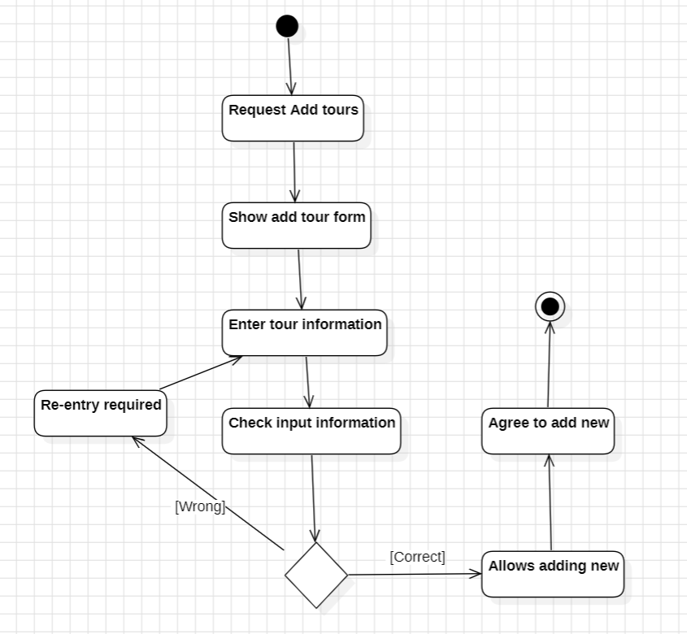
Add Tour Operation Specification
Figure 2.13: Add tour activity specification

Specification for the Add Tour Program Process:
The user requests to add a new tour program.
The system will display the interface for adding a new tour program.
Next, the system prompts the user to enter the required information for the tour

program, such as: tour program code, program name, content, duration, etc.
The user enters the information, and the system checks the input data for validity. The result will return two possible outcomes: Valid or Invalid.
- If the data is valid, the system allows the addition of the tour program, and the new entry is successfully created.
- If the data is invalid, the system will prompt the user to re-enter the information and recheck the data.
The process of adding a new tour program end...

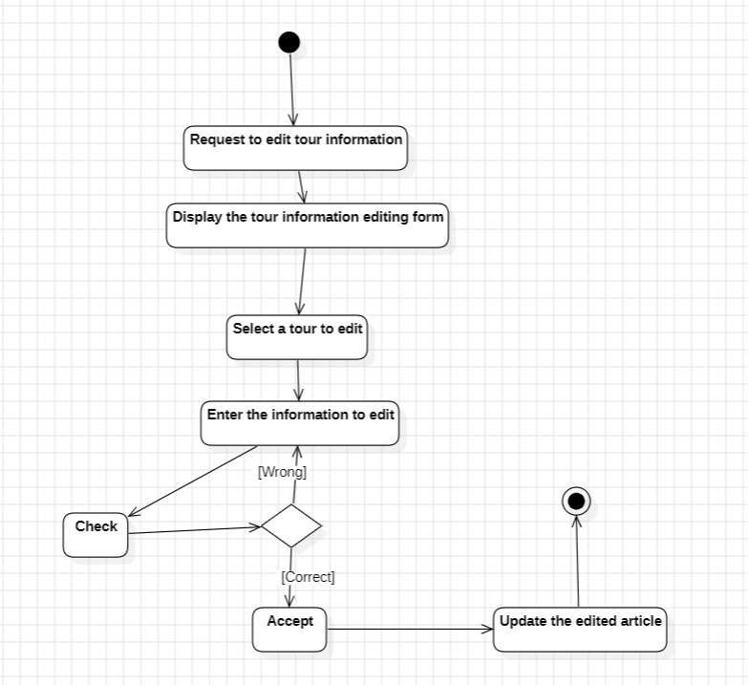
Edit Tour Operation Specification
Figure 2.14: Edit tour operation specification

Specification for the Edit Tour Program Process:
The user requests to edit a tour program, and the system displays the interface for editing the tour program.
The system then asks the user if they wish to proceed with the edit.

The system prompts the user to select the tour program they wish to edit and enter the information they want to modify. After the user enters the updated information, the system checks if the modified data is valid.
- If the entered data is valid, the system accepts the modification. The system then updates the edited information and allows the user to review it before concluding the edit process.
- If the entered data is invalid, the system prompts the user to re-enter the information and returns to the initial input process.
The process of editing the tour program end...

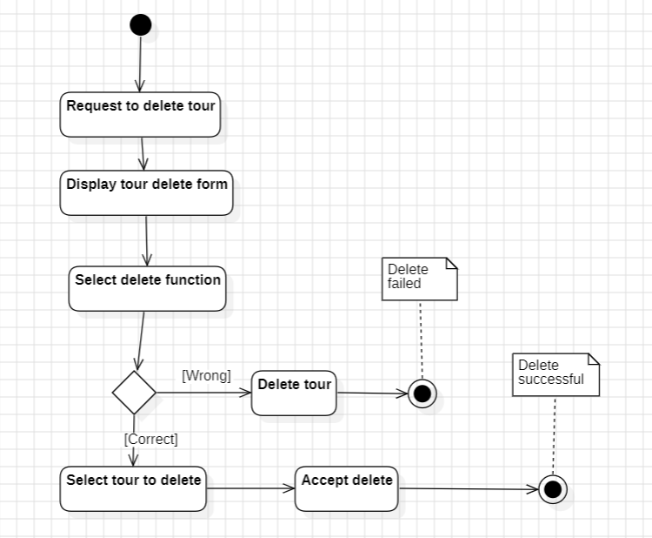
Delete Tour Operation Specification
Figure 2.15: Delete tour operation specification

Specification for the Delete Tour Program Process:
The user requests to delete a tour program.
The system displays the interface for deleting the tour program, where the user can choose to delete a single program or multiple programs at once.
After selecting the delete function for the tour program, the system asks the user for confirmation to ensure they are certain about deleting the program.
- If the user does not agree, the system cancels the deletion process and ends the operation. In this case, the tour program is not deleted.
- If the user agrees, the system prompts the user to select the tour programs they wish to delete and confirms the deletion. The system then displays a success message, confirming that the tour program(s) have been successfully deleted.
The process of deleting the tour program ends.

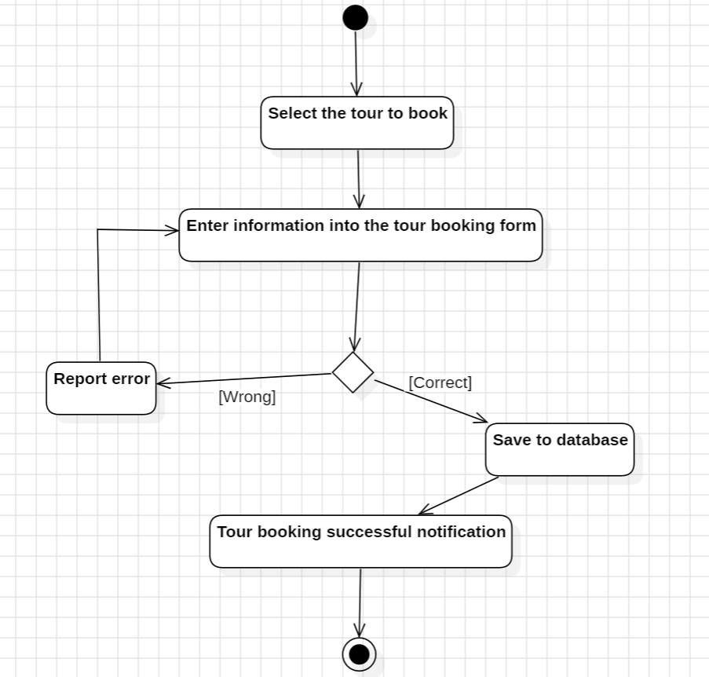
Book Tour Operation Specification
Figure 2.16: Tour booking activity specification

Specification for the Tour Booking Process:
The customer submits a tour booking request on the website.
The system displays the booking interface, and the customer will fill in all the required information.
After the customer enters the information into the booking interface, the system will notify the customer with two possible scenarios:
- If the customer has not provided all the required information, the system will ask the customer to re-enter the missing details.
- If the customer has entered all the required information correctly, the system will save the customer's details into the database. A confirmation email with the tour booking details will be sent to the customer’s email address.
The tour booking process end...

System functions
Based on the problem description and the analysis of the actors, we identify the following use cases:
STT | Function | Describe
1 | Login | This function allows Administrators, Customer Members, and Delivery Staff to log into the system using their accounts to perform their respective  functions
2 | Search | This function helps Administrators and Customers  search for information about articles, products, and Tour packages.
3 | Comment | Customers can write and submit comments. The content and information of the commenter are stored  in the database…
4 | Book tour | This function allows customers to book their desired  tours.
5 | Tour Booking Confirmation Email | After completing the tour booking and the system administrator confirms the tour status, an email will be sent to the customer's account to notify them  about the tour…
6 | View Promotional  Tours | This feature allows displaying promotional tours for  customers to choose from.
7 | Customer Management | This feature enables staff to manage information about member customers, including viewing, adding,  editing, and deleting records.

8 | Comment Management | This feature allows administrators to view, delete, hide, display, and highlight comments.
9 | Tour Management | This feature allows administrators to add, view, edit,  and delete Tour information and images.
10 | Tour Booking Management | This feature enables administrators to update the status of a Tour (confirm the Tour) after a customer has successfully booked it and notify the customer  via an email.
11 | Manage posts | This feature allows the administrator to log in to the  system to add, edit, or delete posts.
12 | View article | This feature allows customers or employees to view  the information of posts.
13 | Decentralized management | This feature allows for detailed role-based access  control, with permissions assigned to each role and specific tasks.

Table 2.3: Table describing the main functions of the system

Analysis
- List of main object classes and relationships

STT | Name | Type | Meaning/Notes
1 | Customer | Main Object Class | Describe detailed information of each customer who has booked a tour, including: full name, gender, age, next  of kin, etc.
2 | Tour | Main Object Class | Describe the tour programs designed, organized, and launched by the company, including: Tour code, tour program name, tour price, start date, end date, etc.
3 | Access – Book Tour | Relationship | Confirm the link for customers to  access the website and reserve a spot for the selected tour.

Table 2.4: List of main object classes and relationships

- Detailed description of main object classes

BOOK_TOURS
STT | Attribute | Data Type | Notes/Significance
1 | ID (Primary key) | BIGINT | Customer booking  identification code
2 | B_TOUR_ID (Foreign key) | BIGINT | Tour code for the booking  order
3 | B_USER_ID (Foreign key) | BIGINT | Customer account code
4 | B_NAME | VARCHAR (255) | Full name of the customer booking the tour
5 | B_EMAIL | VARCHAR (100) | Email of the customer booking the tour
6 | B_PHONE | VARCHAR (100) | Phone number of the  customer booking the tour
7 | B_ADDRESS | VARCHAR (100) | Address of the customer  booking the tour
8 | B_START_DATE | DATE | Expected departure date of  the tour
9 | B_NOTE | TEXT | Notes from the customer  about the tour
10 | B_NUMBER_ADULTS | INT | Number of adults booked
11 | B_NUMBER_CHILDREN | INT | Number of children  booked
12 | B_STATUS | TINYINT | Tour status
13 | CREATED_AT | DATETIME | Creation date
14 | UPDATED_AT | DATETIME | Update date
15 | B_PRICE_ADULTS | INT | Adult price
16 | B_PRICE_ CHILDREN | INT | Child price
Table 2.5: Detailed description table of Tour Booking classes

TOURS
STT | Properties | Data type | Notes/Meaning
1 | ID (Primary key) | BIGINT | Tour Code
2 | T_TITLE | VARCHAR (255) | Name of Tour
3 | T_JOURNEY | VARCHAR (255) | Tour Itinerary
4 | T_SCHEDULE | VARCHAR (255) | Tour Schedule
5 | T_MOVE_METHOD | VARCHAR (255) | Passenger transport
6 | T_STARTING_GATE | VARCHAR (255) | Tour Departure Point
7 | T_START_DATE | DATE | Tour Departure Date
8 | T_END_DATE | DATE | Tour Return Date
9 | T_NUMBER_GUESTS | INT | Number of guests
10 | T_PRICE_ADULTS | INT | Adult price
11 | T_PRICE_CHILDREN | INT | Children's price
12 | T_SALE | INT | Tour discount
13 | T_VIEW | INT | Number of viewers
14 | T_DESCRIPTION | TEXT | Tour description
15 | T_CONTENT | TEXT | Tour introduction
16 | T_ANBUM_IMAGE | TEXT | Tour photo album
17 | T_IMAGE | VARCHAR (255) | Tour pictures
18 | T_LOCATION_ID (Foreign key) | BIGINT | Location code
19 | T_USER_ID (Foreign key) | BIGINT | Account code
20 | T_NUMBER_REGISTERED | INT | Number of people who  booked the tour
21 | T_STATUS | TINYINT | Tour status
23 | T_FOLLOW | INT | Number of customers who registered for the tour but have not  confirmed
24 | CREATED_AT | DATETIME | Date created
25 | UPDATED_AT | DATETIME | Update date

Table 2.6: Detailed description table of the classes of Tour Details

CATEGORIES
STT | Properties | Data type | Notes/Meaning
1 | ID (Primary key) | BIGINT | Category code
2 | C_NAME | VARCHAR (255) | Category name
3 | C_PARENT_ID | INT | Parent category code
4 | C_SLUG | VARCHAR (255) | SEO optimization
5 | C_AVATAR | VARCHAR (255) | Featured image for category
6 | C_BANNER | VARCHAR (255)
7 | C_DESCRIPTION | VARCHAR (255) | Description of the category
8 | C_HOT | TINYINT | Featured now
9 | C_STATUS | TINYINT | Status of the category
10 | C_TYPE | TINYINT | Category Type
11 | C_USER_ID (Foreign key) | BIGINT | User account code
12 | CREATED_AT | DATETIME | Creation time
13 | UPDATED_AT | DATETIME | Update time
Table 2.7: Table detailing the classes of the Catalog

ARTICLES
STT | Properties | Data type | Notes/Meaning
1 | ID (Primary key) | BIGINT | News code
2 | A_TITLE | VARCHAR (255) | News headline
3 | A_SLUG | VARCHAR (255) | SEO optimization
4 | A_SHOW_HOME | TINYINT | Show on home page
5 | A_ACTIVE | TINYINT | Operating status
6 | A_VIEW | INT | News views
7 | A_DESCRIPTION | VARCHAR (255) | Description of the news
8 | A_AVATAR | VARCHAR (1) | News display
9 | A_CONTENT | TEXT | Content of the news
10 | A_CATEGORY_ID  (Foreign key) | BIGINT | Category code
11 | A_USER_ID (Foreign key) | BIGINT | User account code
12 | CREATED_AT | DATETIME | News creation date
13 | UPDATED_AT | DATETIME | News update date

Table 2.8: Detailed description of News classes

HOTELS
STT | Properties | Data type | Notes/Meaning
1 | ID (Primary key) | BIGINT | Hotel code
2 | H_NAME | VARCHAR (255) | Hotel name
3 | H_IMAGE | VARCHAR (255) | Hotel images
4 | H_ADDRESS | VARCHAR (255) | Hotel address
5 | H_PHONE | VARCHAR (255) | Contact phone number
6 | H_ANBUM_IMAGE | TEXT | Hotel photo album
7 | H_PRICE | INT | Hotel prices
8 | H_PRICE_CONTACT | TINYINT | Price contact hotel
9 | H_SALE | INT | Hotel promotions
10 | H_DESCRIPTION | TEXT | Hotel Description
11 | H_CONTENT | TEXT | Hotel content
12 | H_STATUS | TINYINT | Hotel status
13 | H_LOCATION_ID  (Foreign key) | BIGINT | Location code
14 | H_USER_ID (Foreign key) | BIGINT | User account code
15 | CREATED_AT | DATETIME | Creation time
16 | UPDATED_AT | DATETIME | Update time
Table 2.9: Table detailing the Hotel classes

COMMENTS
STT | Properties | Data type | Notes/Meaning
1 | ID (Primary key) | BIGINT | Comment code
2 | CM_REPLY_ID | BIGINT | Comment reply code
3 | CM_USER_ID (Foreign  key) | BIGINT | User account code
4 | CM_ARTICLE_ID  (Foreign key) | BIGINT | News code
5 | CM_HOTEL_ID (Foreign  key) | BIGINT | Hotel code
6 | CM_TOUR_ID (Foreign  key) | BIGINT | Tour code
7 | CM_CONTENT | TEXT | Comment content
8 | CM_IMAGES | TEXT | Comment image
9 | CM_STATUS | TINYINT | Comment status
10 | CREATED_AT | DATETIME | Date created

11 | UPDATED_AT | DATETIME | Update date
Table 2.10: Table detailing the classes of Comments
LOCATIONS
STT | Properties | Data type | Notes/Meaning
1 | ID (Primary key) | BIGINT | Location code
2 | L_NAME | VARCHAR (255) | Tourist destination name
3 | L_SLUG | VARCHAR (255) | Search
4 | L_IMAGE | VARCHAR (255) | Location image
5 | L_DESCRIPTION | VARCHAR (255) | Description of location
6 | L_CONTENT | TEXT | Location content
7 | L_STATUS | TINYINT | Location status
8 | L_USER_ID (Foreign key) | BIGINT | User account code
9 | CREATED_AT | DATETIME | Date created
10 | UPDATED_AT | DATETIME | Update date
Table 2.11: Table detailing the layers of the Location

CONTACTS
STT | Properties | Data type | Notes/Meaning
1 | ID (Primary key) | BIGINT | Contact code
2 | NAME | VARCHAR (255) | Name to contact the  website
3 | E-MAIL | VARCHAR (255) | Enter email to contact  website
4 | SUBJECT | VARCHAR (255) | Object
5 | MESSAGE | TEXT | Enter contact information
6 | C_USER_ID (Foreign key) | BIGINT | User account code
7 | CREATED_AT | DATETIME | Date created
8 | UPDATED_AT | DATETIME | Update date
Table 2.12: Detailed description of Contact classes

USERS
STT | Properties | Data type | Notes/Meaning
1 | ID (Primary key) | BIGINT | Member account code
2 | NAME | VARCHAR(255) | Account display name
3 | E-MAIL | VARCHAR(255) | Account Email
4 | PHONE | VARCHAR(255) | Account phone number
5 | EMAIL_VERIFIED_AT | DATETIME | Confirm registered email
6 | PASSWORD | VARCHAR(255) | Account password
7 | AVATAR | VARCHAR(255) | Account avatar
8 | ADDRESS | VARCHAR(255) | Address of the account
9 | STATUS | TINYINT | Account Status
10 | REMEMBER_TOKEN | VARCHAR(100) | Remember token
11 | CREATED_AT | DATETIME | Date created
12 | UPDATED_AT | DATETIME | Update date
Table 2.13: Detailed description table of User classes

GROUP_PERMISSION
STT | Properties | Data type | Take  note | Note/Meaning
1 | ID (Primary key) | BIGINT | Code | Licensing  Group
2 | NAME | VARCHAR(255) | License management group  name
3 | DESCRIPTION | VARCHAR(255) | Management Team  Description
4 | CREATED_AT | DATETIME | Date created
5 | UPDATED_AT | DATETIME | Update date
Table 2.14: Detailed description table of the classes of the Authorization Group

PERMISSIONS
STT | Properties | Data type | Notes/Meaning
1 | ID (Primary key) | BIGINT | Management Code
2 | NAME | VARCHAR(255) | Name of management rights
3 | DISPLAY_NAME | VARCHAR(255) | Display name
4 | DESCRIPTION | VARCHAR(255) | Description of management  rights
5 | GROUP_ PERMISSION_ID  (Foreign key) | BIGINT | Management group code
6 | CREATED_AT | DATETIME | Date created
7 | UPDATED_AT | DATETIME | Update date
Table 2.15: Detailed description of the layers of Decentralization

PERMISSION_ROLE
STT | Properties | Data type | Notes/Meaning
1 | PERMISSION_ID (Primary key)  (Foreign key) | BIGINT | License code
2 | ROLE_ID (Primary key)  (Foreign key) | BIGINT | Role code
Table 2.16: Detailed description table of the layers of Role Delegation

ROLES
STT | Properties | Data type | Notes/Meaning
1 | ID (Primary key) | BIGINT | Role code
2 | NAME | VARCHAR(255) | Role Name
3 | DISPLAY_NAME | VARCHAR(255) | Display name of the role
4 | DESCRIPTION | VARCHAR(255) | Description of role
5 | CREATED_AT | DATETIME | Date created
6 | UPDATED_AT | DATETIME | Update date
Table 2.17: Detailed description table of Role classes

ROLE_USER
STT | Properties | Data type | Notes/Meaning
1 | ROLE_ID (Primary key)  (Foreign key) | BIGINT | Role code
2 | USER_ID (Primary key)  (Foreign key) | BIGINT | Account code
Table 2.18: Detailed description table of User Role classes

PASSWORD_RESETS
STT | Properties | Data type | Notes/Meaning
1 | E-MAIL | VARCHAR(255) | Email registered account
2 | TOKEN | VARCHAR(255) | Token code
3 | CREATED_AT | DATETIME | Date created
Table 2.19: Table detailing the layers of Password Reset

Data design
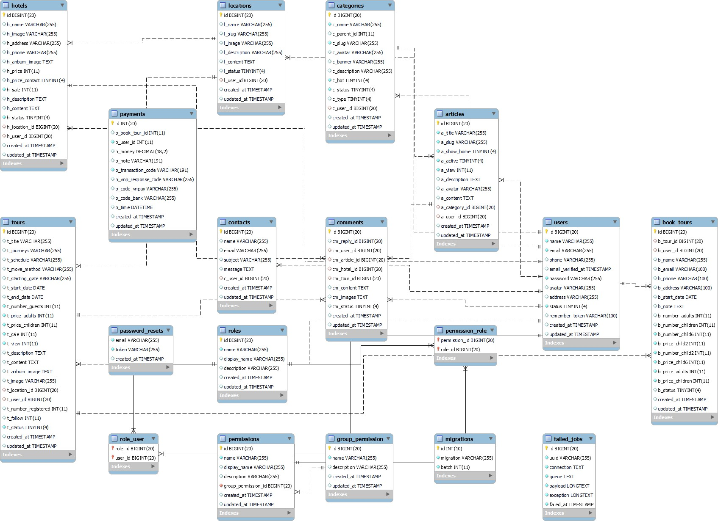

Figure 2.17: Relational schema diagram

CHAPTER 3. TECHNOLOGY SOLUTIONS

  - Technologies Related to Chatbots
- Rasa (Open Source)
Overview:
Rasa is an open-source framework for building AI-powered chatbots and virtual assistants. Unlike Dialogflow, Rasa allows developers to host and customize their bots on-premise or in private cloud environments, offering full control over the data and architecture.

Key Features:
Rasa NLU (Natural Language Understanding): Processes and interprets user inputs by extracting intents and entities.
  - Rasa Core: Manages conversational flows using machine learning-based dialogue policies.
  - Custom Training: Supports custom NLP models tailored to the tourism domain, such as extracting data specific to tours, destinations, or dates.
  - Data Privacy: Since Rasa is self-hosted, it ensures higher data security, which is critical in managing sensitive customer information.
  - Flexible Integration: Can be connected to a variety of platforms and third- party APIs, allowing seamless integration with existing systems.

GPT (OpenAI API)

Overview:
GPT (Generative Pre-trained Transformer) is a state-of-the-art AI language model developed by OpenAI. It is designed for natural language generation and understanding tasks. GPT can handle complex inquiries, provide detailed explanations, and engage in highly conversational exchanges.

Key Features:
Contextual Understanding: Analyzes the context of conversations to provide relevant and accurate responses.
  - Pre-trained Model: Built on extensive datasets, making it capable of understanding a wide range of topics, including tourism.
  - Custom Fine-Tuning: Supports domain-specific fine-tuning, allowing the chatbot to specialize in tour booking scenarios.
  - Multi-language Support: Handles inputs and outputs in multiple languages, making it ideal for international users.
  - Advanced Text Generation: Provides natural and human-like responses, improving customer satisfaction and engagement.

Natural Language Processing (NLP) Tools Spacy:
  - A Python library for advanced NLP tasks, including tokenization, part-of-speech
tagging, and dependency parsing.

NLTK (Natural Language Toolkit):
  - A comprehensive library for working with human language data, including text classification, parsing, and semantic reasoning.

Dialogflow (Google) Overview:
Dialogflow is a conversational AI platform provided by Google, designed to develop
chatbots and virtual agents. It utilizes Natural Language Processing (NLP) to interpret and process user input and deliver contextually relevant responses. Dialogflow works with various channels such as websites, mobile apps, and social media platforms like Facebook Messenger or Telegram.

Key Features:
Intent Recognition: Identifies the purpose behind user inputs (e.g., booking a tour, asking for details about a destination).
  - Entity Extraction: Extracts specific data points such as dates, names, or locations from the conversation.
  - Prebuilt Agents: Offers prebuilt agents for rapid deployment in common use cases, reducing development time.
  - Integration with Google Cloud: Provides robust scalability, secure hosting, and analytics through Google Cloud services.
  - Multilingual Support: Supports over 20 languages, enabling communication with a global audience.

Reason for Selection:
Ease of Integration: Dialogflow's RESTful APIs make it straightforward to connect with the Laravel backend.
  - Scalability: Fully managed by Google Cloud, making it reliable for handling a growing number of users.
  - Cost-effectiveness: Flexible pricing based on usage, making it suitable for both small-scale and enterprise-level projects.
  - Rich Documentation: Comprehensive guides and community support simplify the development process.

Technologies Related to PHP and Laravel
- PHP Language
  - Description: PHP is a server-side programming language widely used for web application development. It is particularly effective when combined with MySQL databases.

Reason for Selection:
    - Simple and easy to learn, reducing the project development time.
    - High compatibility with most web servers.
    - Well-suited for integrating APIs of chatbots (e.g., Dialogflow or GPT APIs).

Laravel Framework
  - Description: Laravel is a modern PHP framework designed to simplify and accelerate the development of web applications. It provides a comprehensive ecosystem with powerful tools.

Key Features and Reasons for Selection:
Artisan (Command-line Tool):
- Speeds up the development process by automating tasks like file structure creation, running migrations, and seeding data.
- Facilitates repetitive tasks such as database management or API integration.

Blade Template Engine:
- A template engine for managing frontend interfaces, simplifying the development of dynamic web pages.
- Allows easy customization of the tour management dashboard.

Eloquent ORM:
- Provides an intuitive and efficient way to interact with MySQL databases.
- Minimizes errors in querying and managing data.

Middleware:
- Ensures security for HTTP requests.
- Facilitates secure and structured integration of chatbot APIs.

Scalability:
- Laravel offers robust tools to expand functionalities as user and data volumes increase.

MySQL (Database)
  - Description: MySQL is one of the most widely used relational database management systems.

Reason for Selection:
    - High performance, suitable for medium-sized web applications.
    - Easy integration with Laravel through Eloquent ORM.
    - Efficiently manages customer, tour, and booking data in a structured manner.

Summary of Technology Selection Reasons
    - Ease of Integration: Technologies like Laravel and Dialogflow provide built- in tools for seamless API integration, enabling smooth operation between the chatbot and the tour booking management system.
    - Performance and Security: Laravel ensures high processing performance while offering advanced security features to protect customer data.
    - Flexibility: Rasa and GPT offer customizable and natural conversational capabilities, meeting the complex requirements of the tourism domain.
    - Rapid Development: Laravel's tools like Artisan and Blade Template Engine reduce development time and allow a focus on core functionalities.
    - Scalability: Technologies like Laravel and Dialogflow are designed to scale, ensuring the system can handle increasing user traffic and data in the future.

CHAPTER 4. IMPLEMENTATION RESULTS

Implementation and Testing
        - The website is built using HTML, combined with the PHP programming language (Laravel Framework).
        - Design and Development Tools: Visual Studio Code, Sublime Text
        - Operating Systems: Windows 10, macOS
        - Database Management Systems: MySQL, phpMyAdmin, Microsoft SQL Server 2019
        - Data Connection Method: MySQLi (MySQL Improved)
        - Supporting Software: Laragon, XAMPP, etc…

Steps to Complete the Project
- Preparation:
- Create a detailed project plan.
- Research and refer to the following resources:
- HTML
- SQL Server
- phpMyAdmin
- Framework Laravel
- Understand the business operations and organization of the travel company’s tour programs.
- Research, gather information, and prepare data for the website.
- Execution:
- Develop a functional diagram and interactions between the website pages.
- Design the database and data relationships.
- Design the website interface.
- Create templates based on the designed interface.
- Program the content display for the website using the created templates.
- Implement data search functionality for travel tours.
- Program the booking form processing for customer tour reservations.
- Encrypt sensitive information during updates.
- Program dynamic content updates for the website.
- Program the customer tour booking management system.
- Program the management of customer information and member customers.
- Implement role-based access control for website administration.

- Finalization:
- Verify the accuracy of the website’s content display.
- Test the information search functionality.
- Test the admin role-based access control.
- Test the management of customer tour bookings.
- Test the encryption of database information and the website’s security.
- Conduct comprehensive testing and finalize the website.
- Prepare the project design report.

Interface Design

Detailed Interface Descriptions
The homepage of the tour booking website is divided into several sections, arranged in a logical order to highlight the organized structure of a professional website.
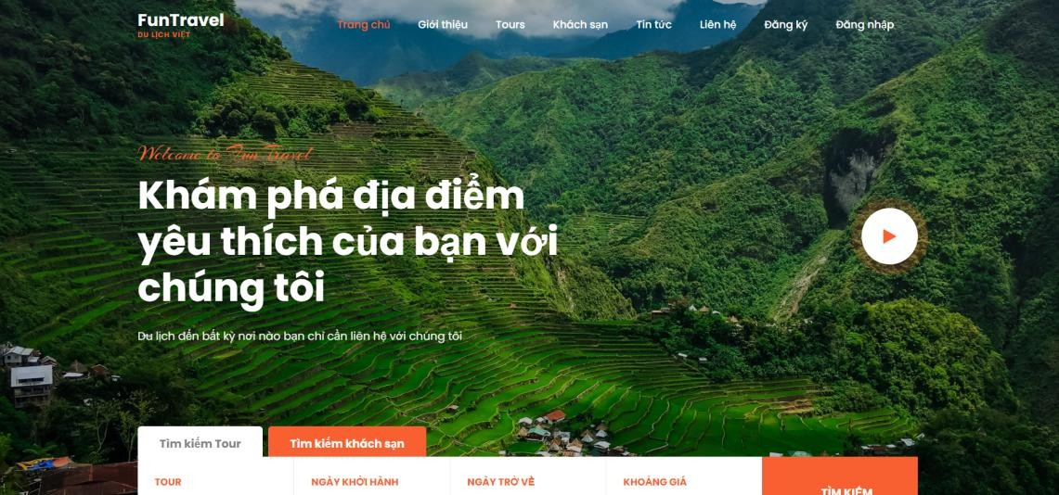
Figure 4.1: Main interface screen

Highlighted Tours Interface:
Our service offers the most popular tour programs that customers have booked the most this month, based on sales analytics from our website. These tours not only meet customers' travel needs but are also optimized to provide the highest convenience and satisfaction.

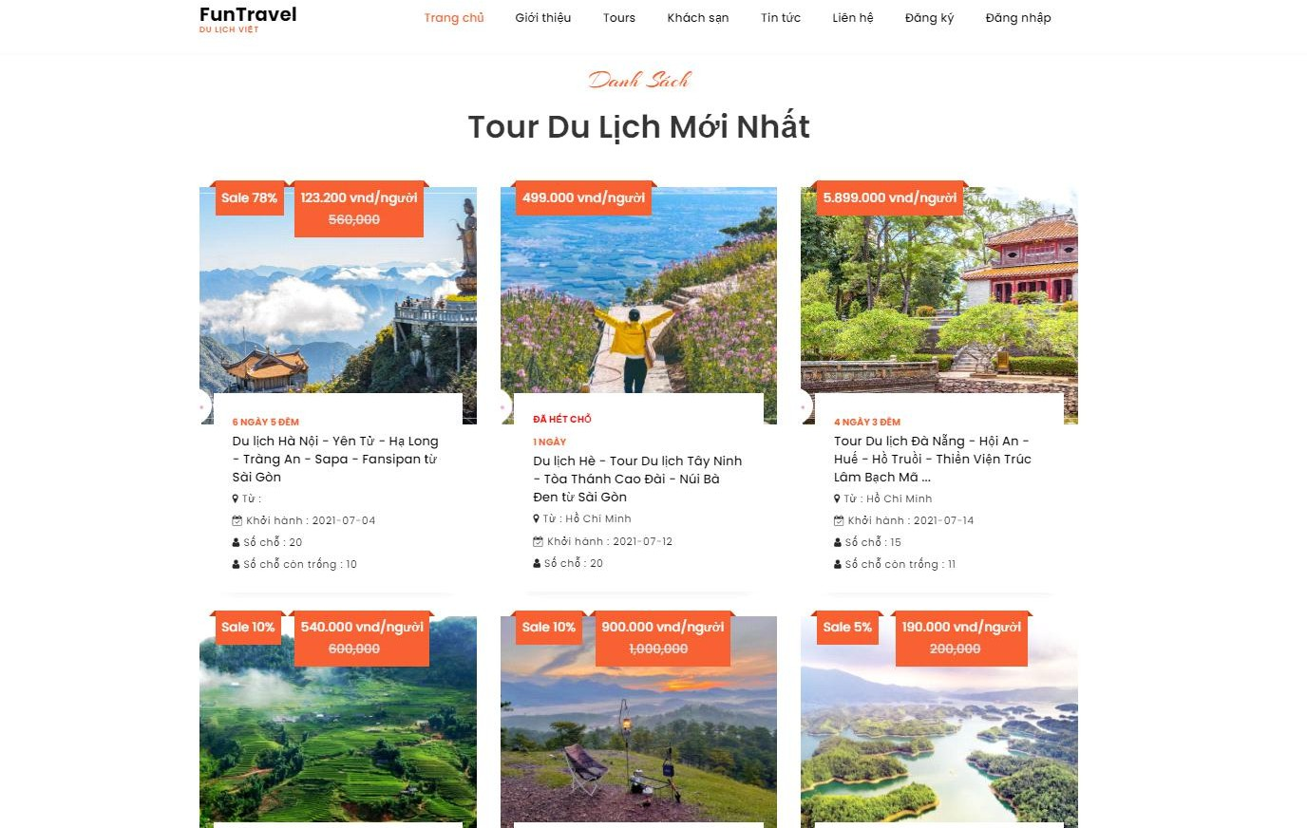
Figure 4.2: Home screen showing featured Tours

Tourism News Interface:
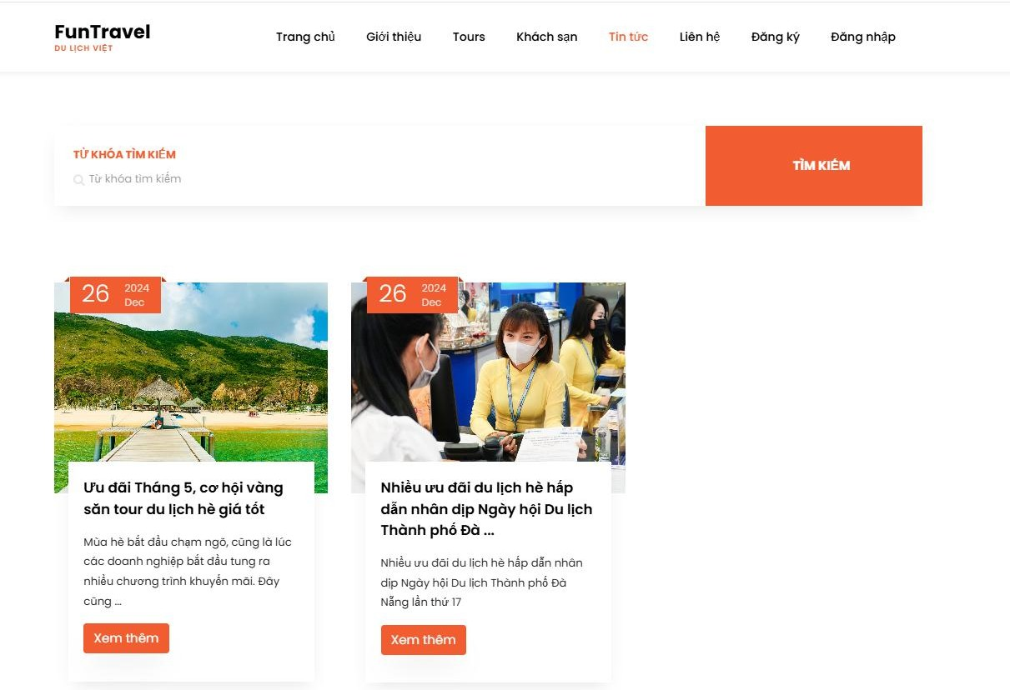
This is a news platform aimed at promoting tourism information as well as providing useful travel guides. It is designed to support customers with a more comprehensive understanding of travel..
Figure 4.3: Home screen showing Travel News

Contact Interface:
This platform allows customers to view all information on the website, such as terms and conditions, contact details, and promotional policies.

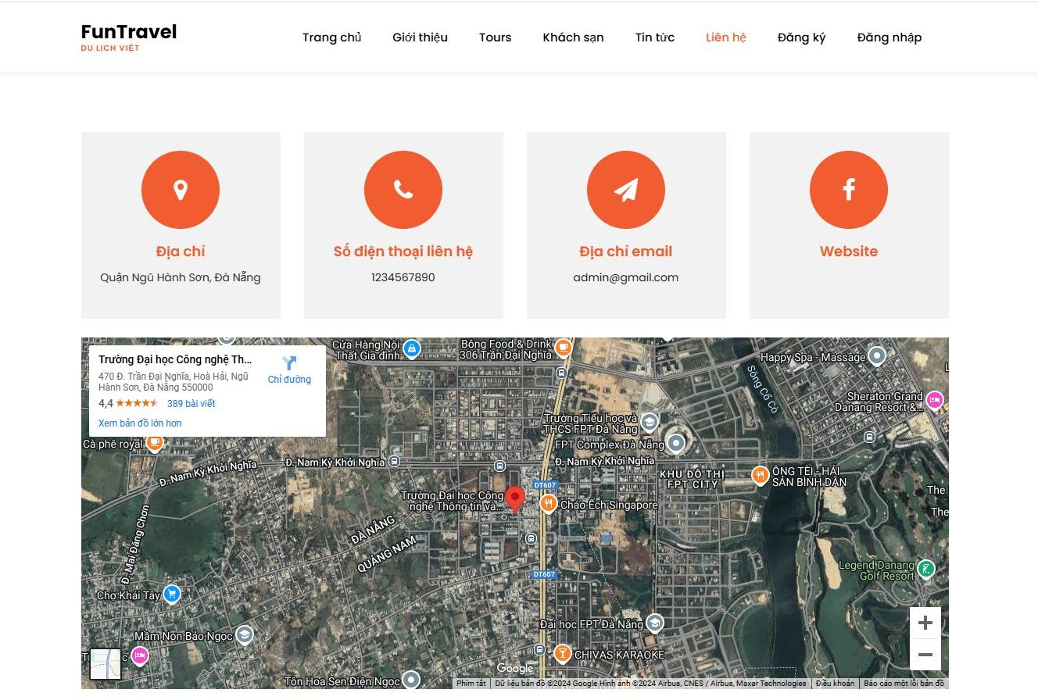
Figure 4.4: Home screen of contact us section

Membership Registration Interface:
This is a membership registration page for customers. By signing up as a member, customers can receive exclusive benefits from us.

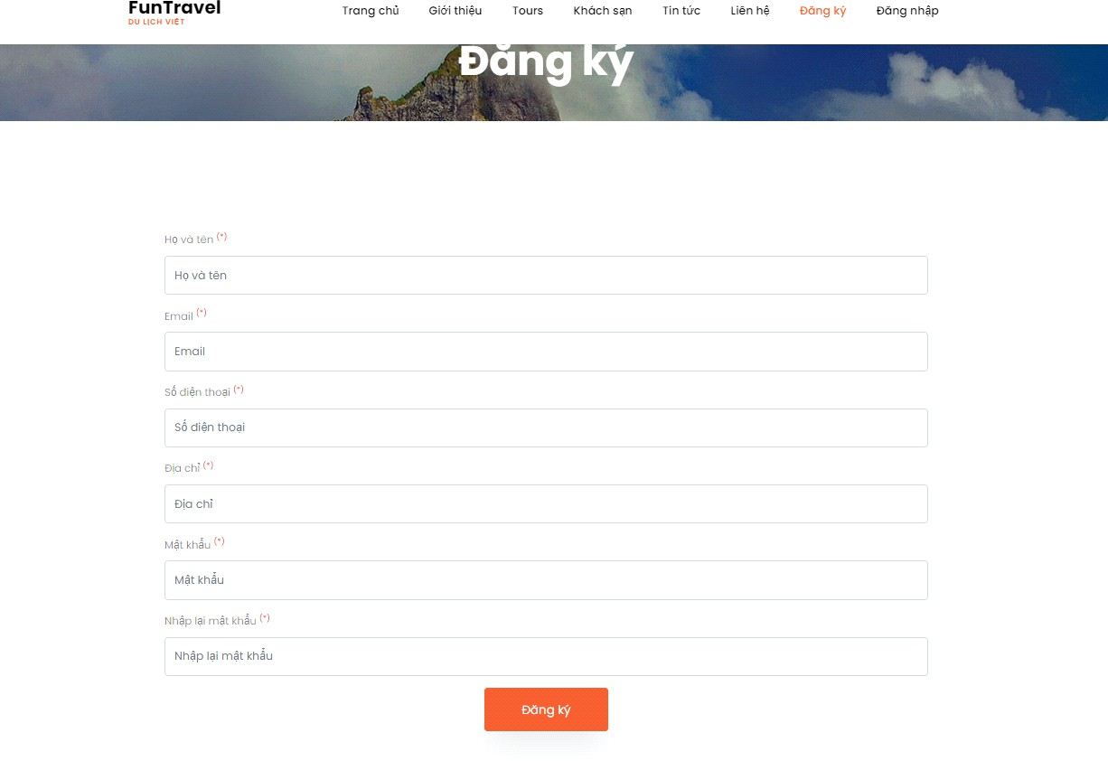
Figure 4.5: Customer registration screen

Tour Program Details Interface:
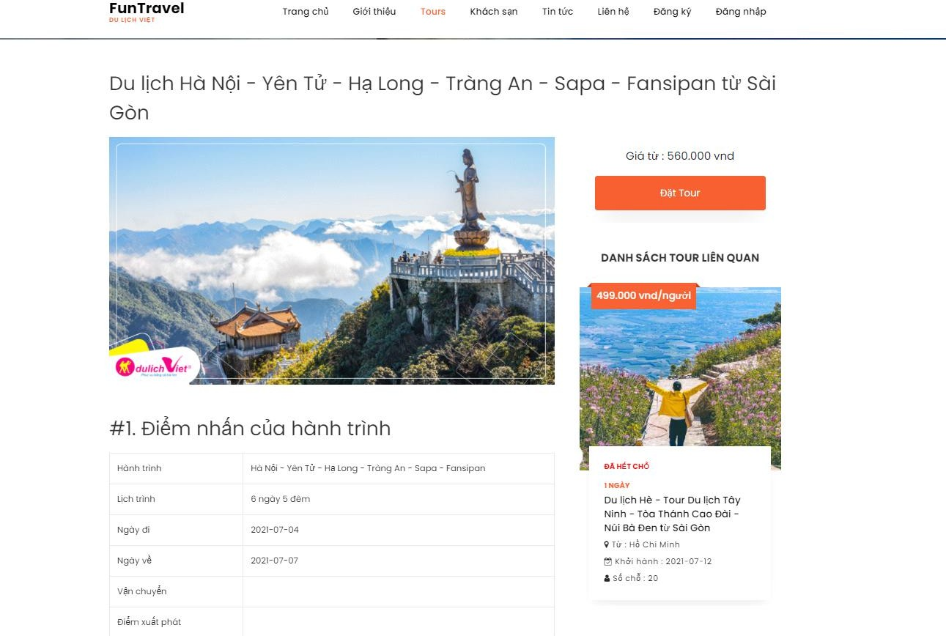
This is the page introducing the travel tour programs currently available on the website.
Figure 4.6: Tour Program Details Interface

Tour schedule interface screen, Tour introduction
Provide detailed itineraries for the tour programs, with clear and specific introductions to each tour, ensuring customers can visualize the experience as clearly as possible.

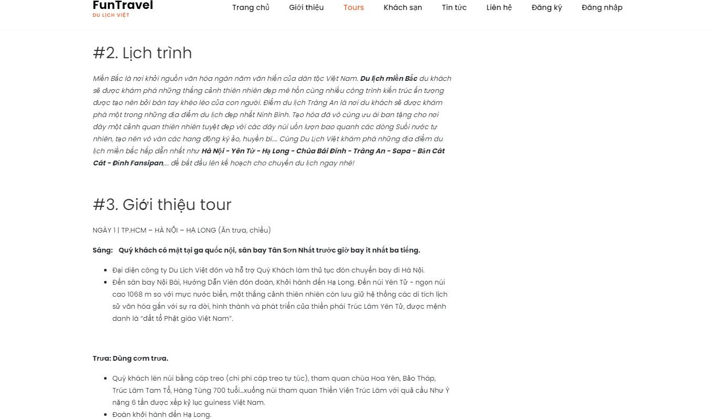

Figure 4.7: Tour schedule interface screen, Tour introduction

Tour Comments Interface:
This interface is designed for customers who have commented on our tours to objectively evaluate the quality of the tours.
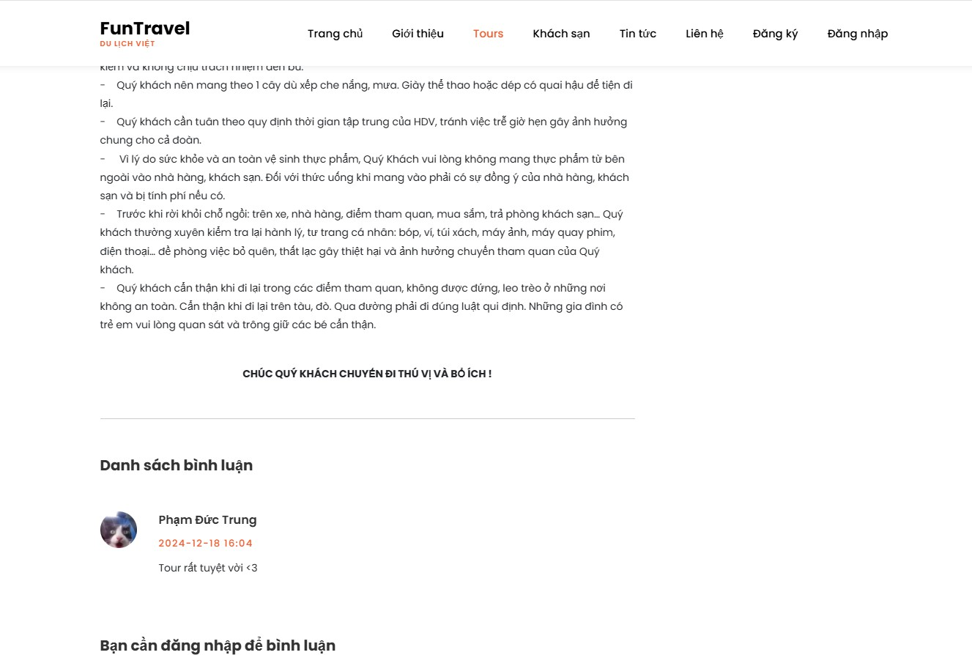
Figure 4.8: Tour Comments Interface

Tour booking interface screen
After the customer selects a desired tour, they will fill in their personal information and details of accompanying travelers in the required interface, so that we can proceed with information verification.
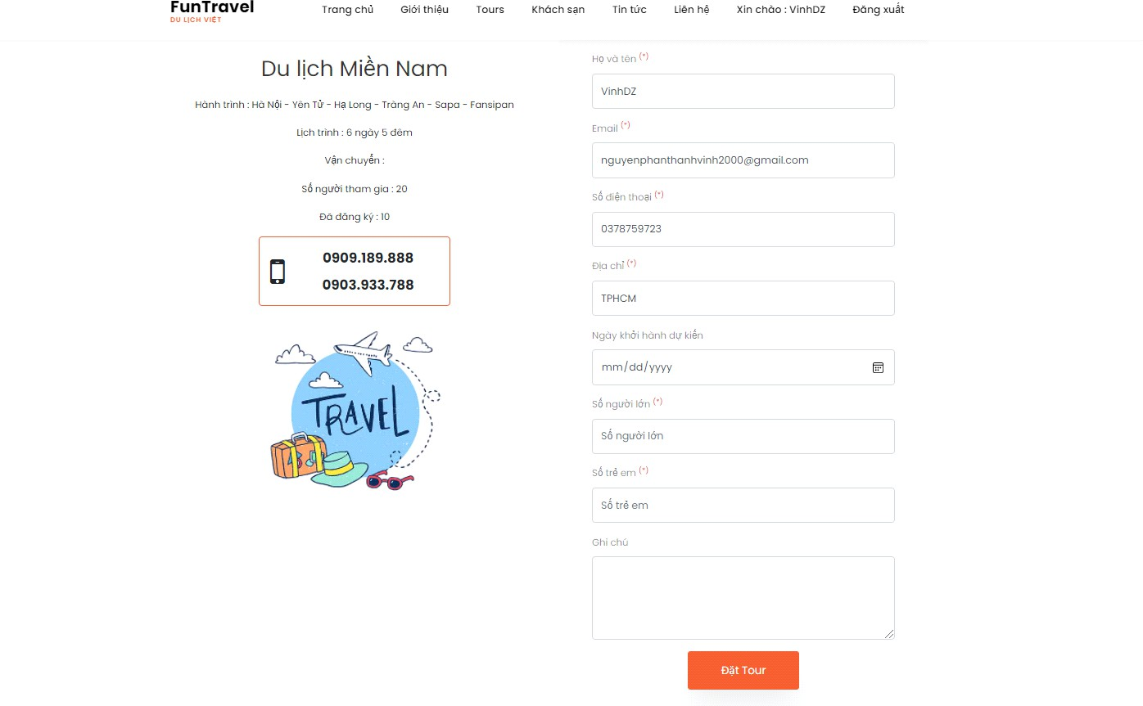
Figure 4.9: Tour booking interface screen

Hotel Interface:
This interface is designed for customers to view the quality and reference prices of hotels.
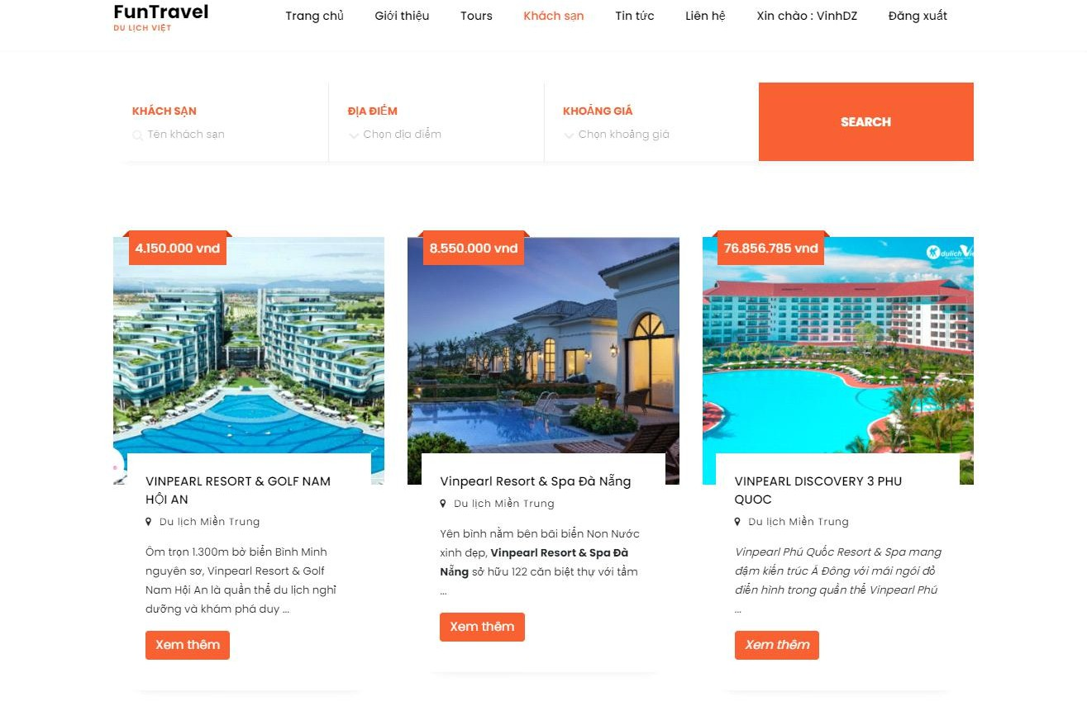
Figure 4.10: Hotel Interface

Detailed Descriptions of Administrative Interfaces

Admin Dashboard Interface
This is the dashboard interface of the management page, including statistics on the number of tours, booked tours, number of members, and total posts.
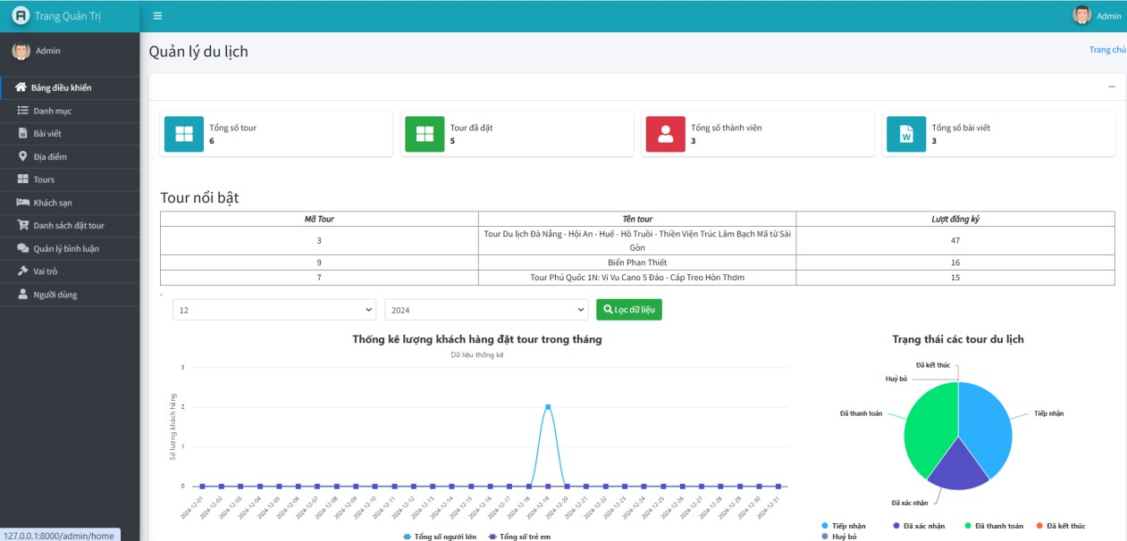

Figure 4.11: Admin Dashboard Interface

Tour Category Management Interface
This interface allows administrators to manage categories, making it easier to organize and classify articles.
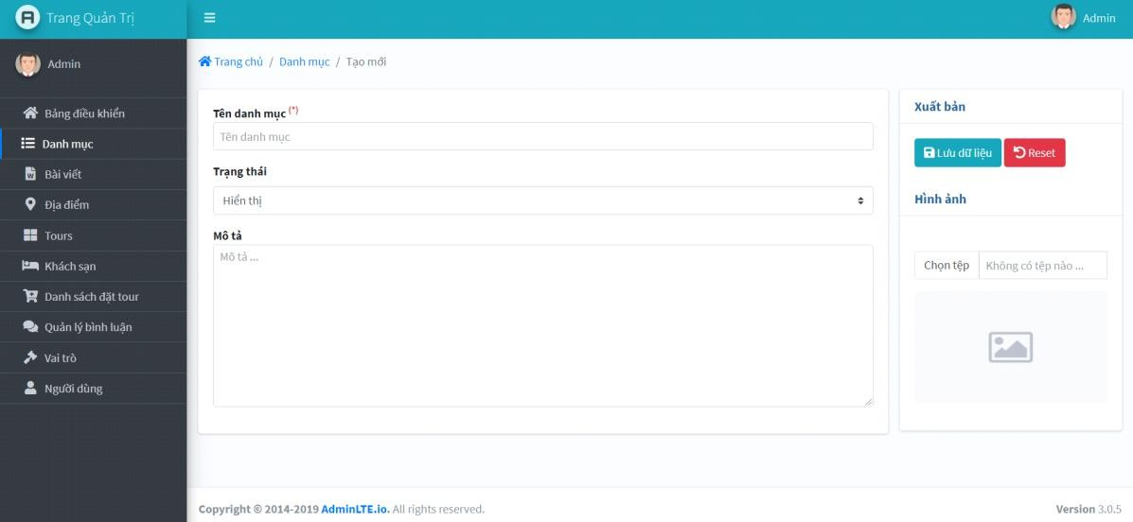
Figure 4.12: New Category management interface screen

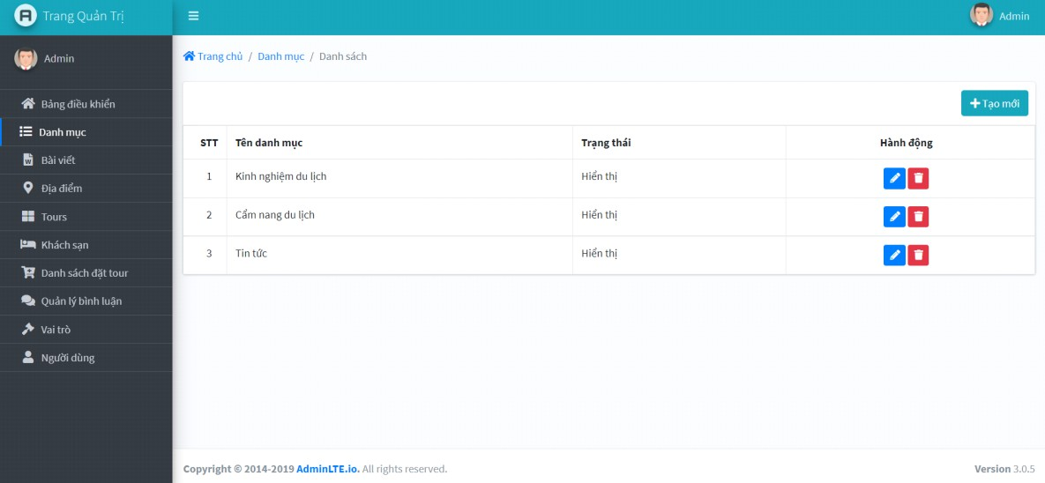
Figure 4.13: Category list management interface screen

Travel Articles Management Interface
This interface enables administrators to update tourism-related articles to provide customers with the latest information.
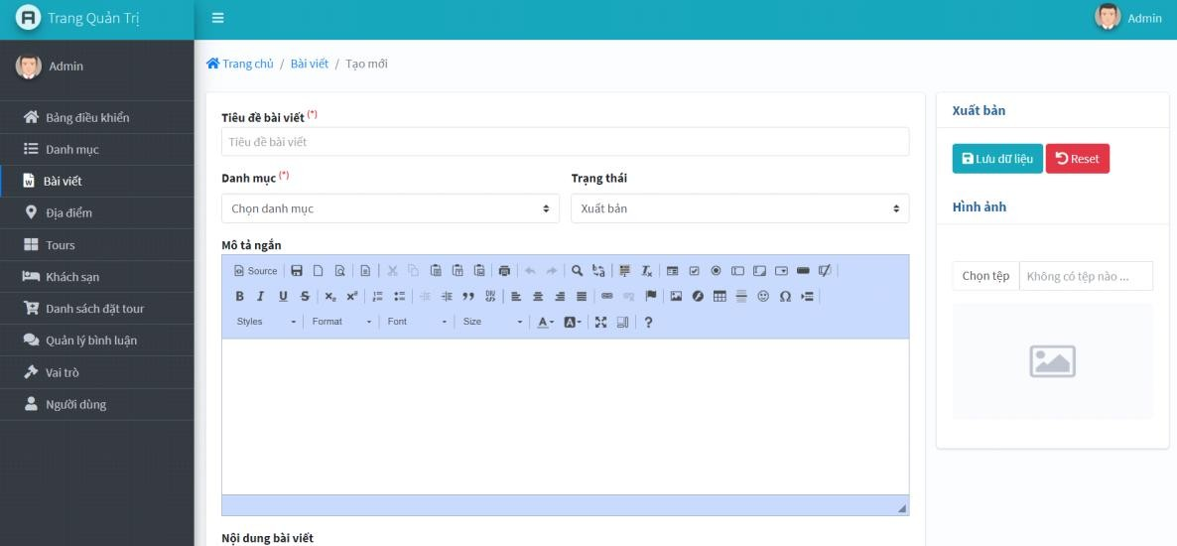
Figure 4.14: Management interface screen to create new News article

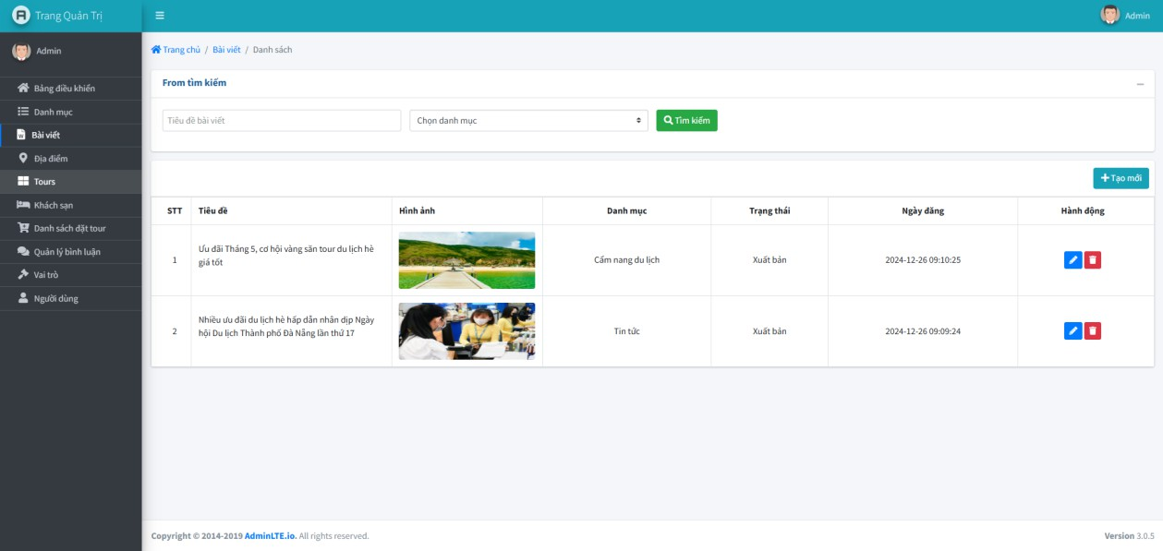
Figure 4.15: News article management interface screen

Tour Location Management Interface
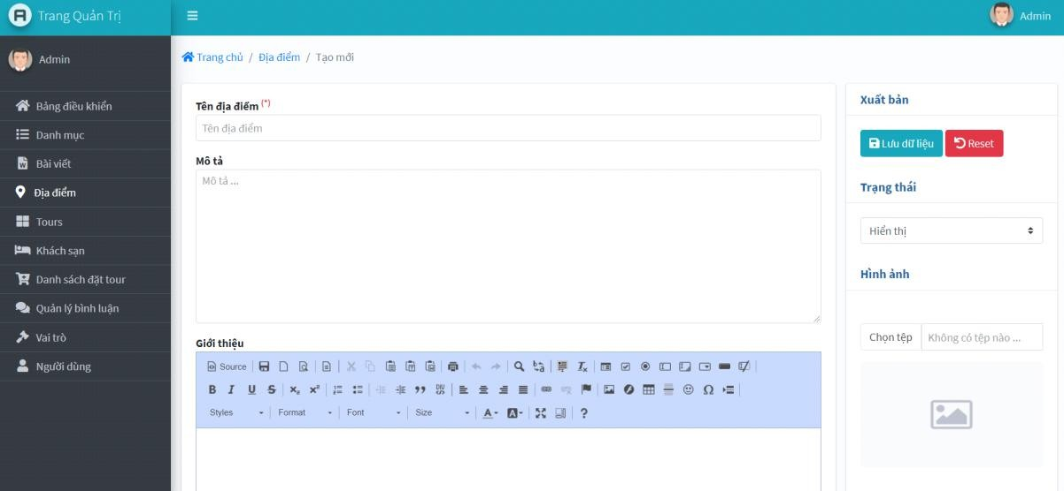
Administrators can manage travel destinations and areas through this interface.
Figure 4.16: Tour Location Management Interface

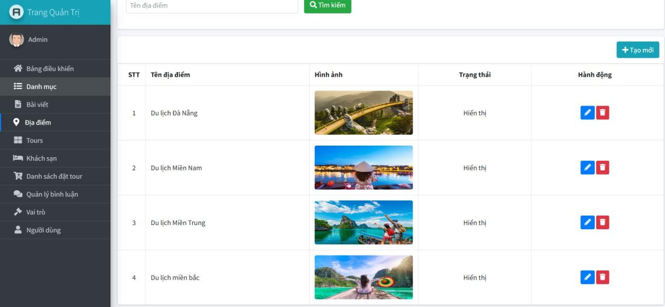

Figure 4.17: Tour Location management interface screen

Tour Program Management Interface
This interface allows administrators to manage ongoing tour programs or create new tours based on company requirements.
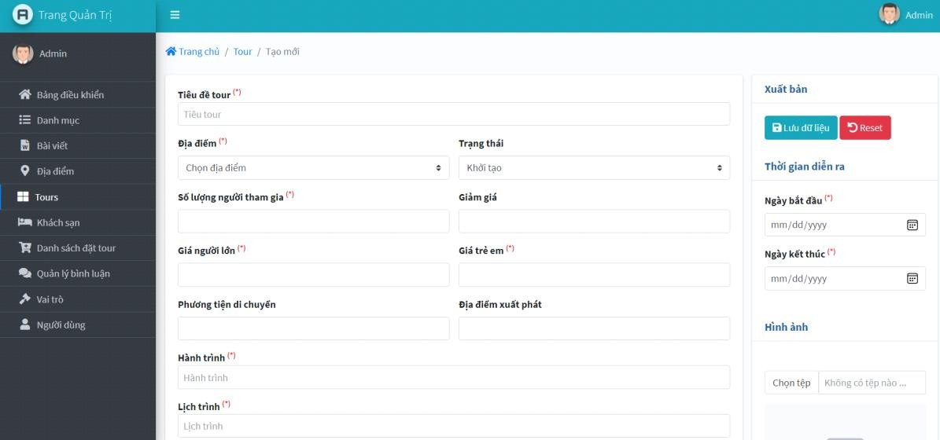
Figure 4.18: Tour Program Management Interface

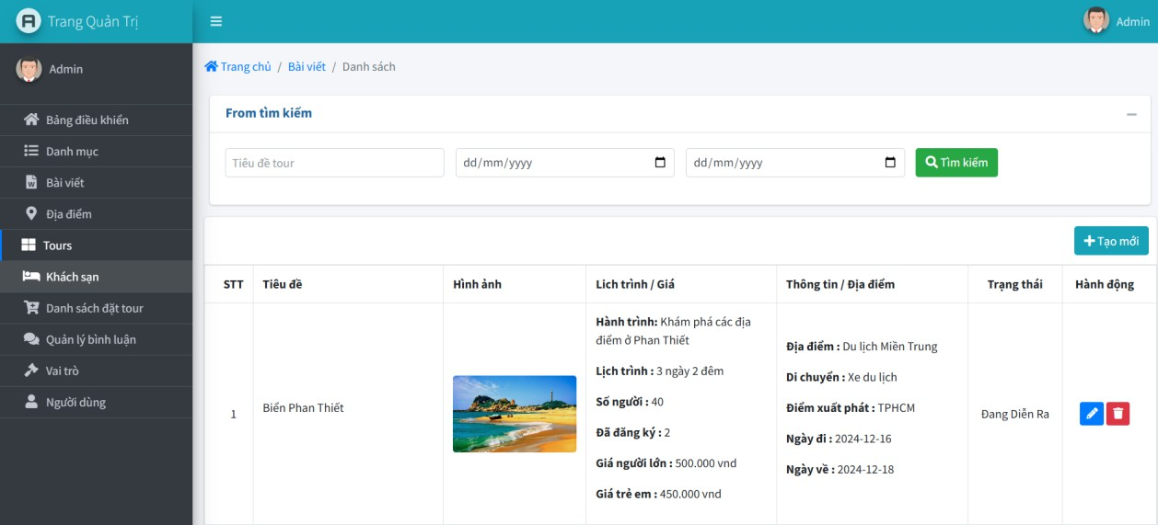

Figure 4.19: Tour Program management screen

Tour Booking Management Interface
This interface lets administrators manage customer booking details and their accompanying members.
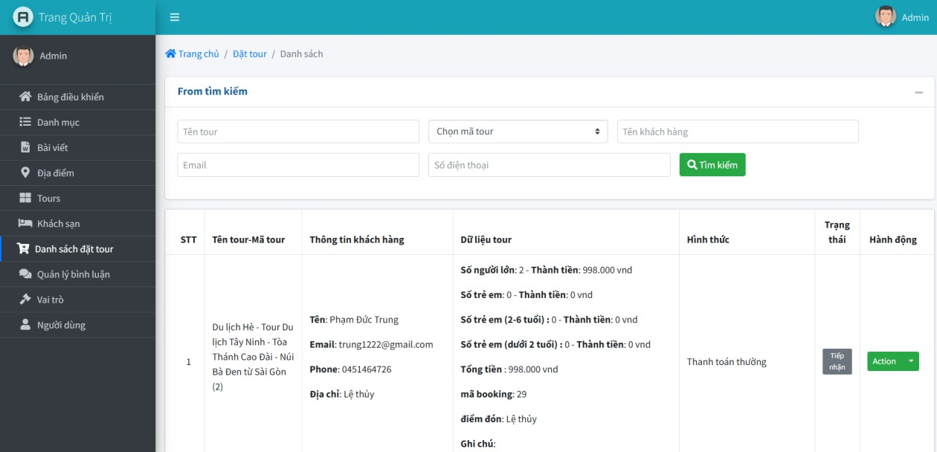
Figure 4.20: Tour booking management interface screen

Hotel Management Interface
Administrators can manage hotel information, including adding, editing, and deleting hotel records.

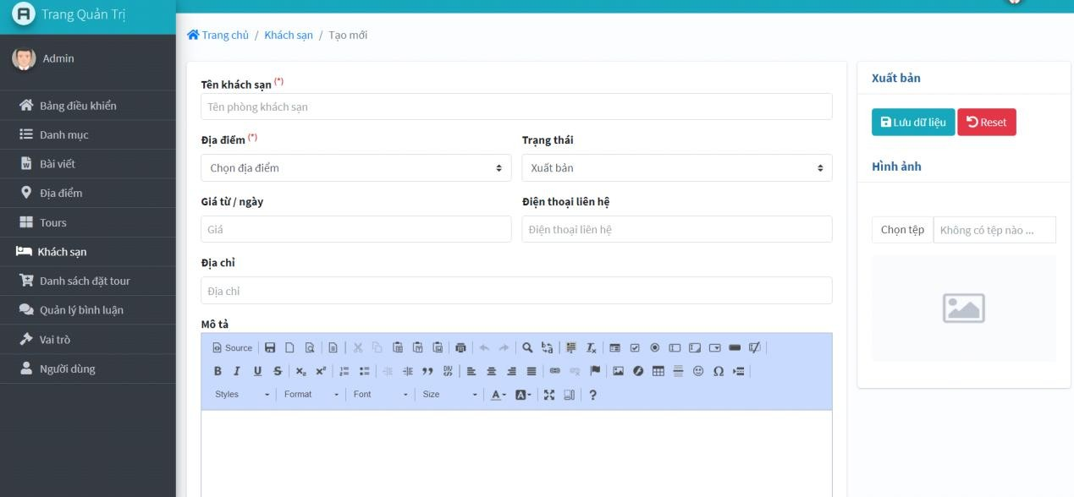
Figure 4.21: Hotel management interface screen
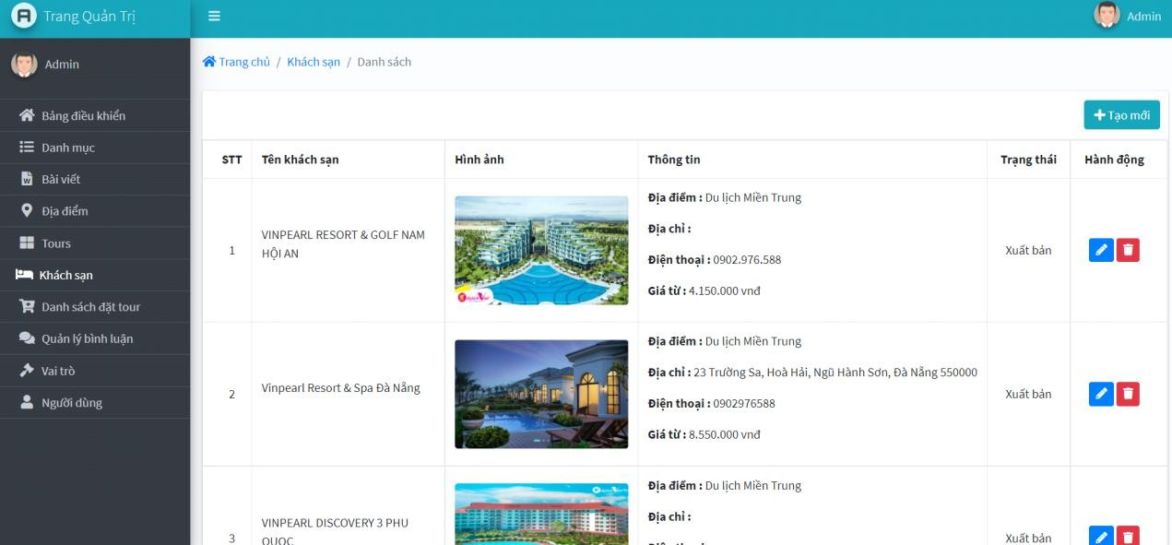

Figure 4.22: Hotel management interface screen

Tour Comments Management Interface
Administrators can manage customer comments on tours, approve or reject comments for public display.

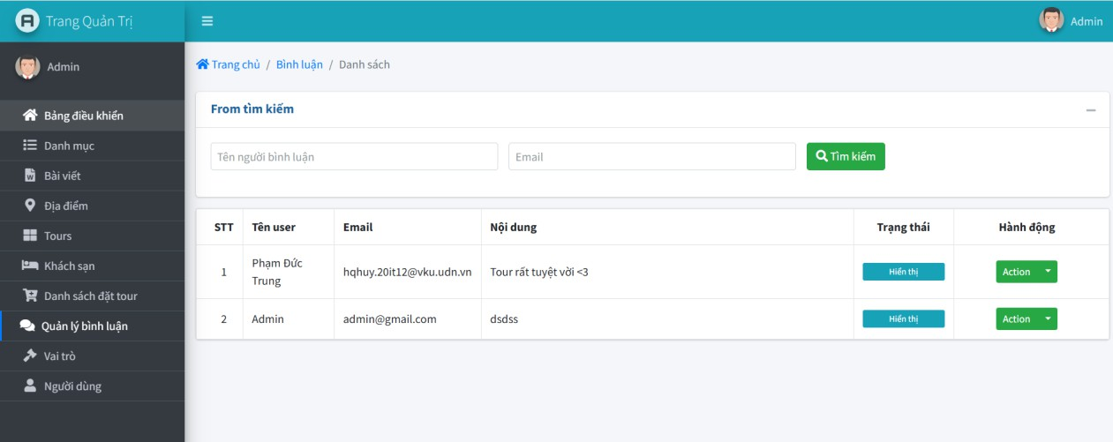
Figure 4.23: Comment management interface screen

User Role Management Interface
This interface allows administrators to manage roles for different account types, such as customers, employees, and administrators.
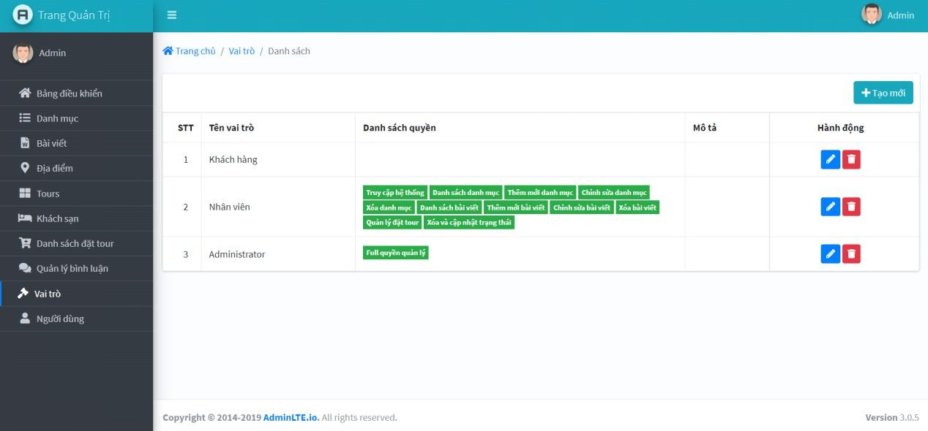
Figure 4.24: Account Role Management Interface Screen

User Account Management Interface
Through this interface, administrators can manage user accounts, including adding, editing, and deleting account details.

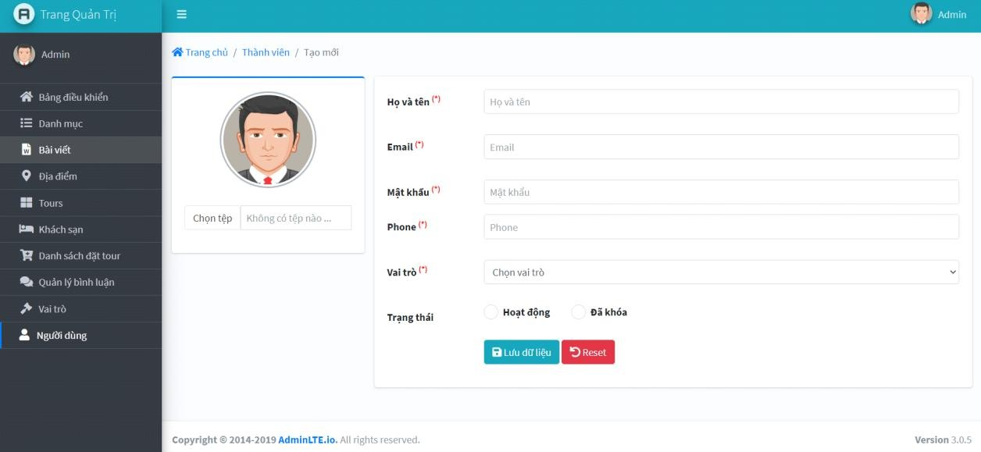
Figure 4.25: User account management interface screen
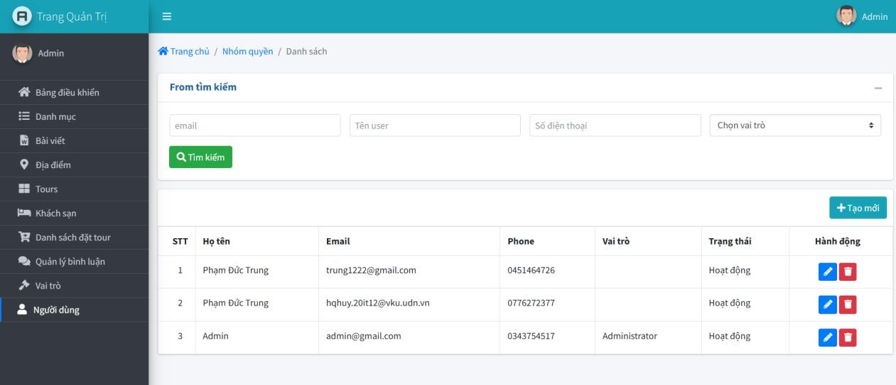
Figure 4.26: User account management interface screen

Chatbot AI
Chatbot provides travel information, such as tours, activities, and destinations, offering details like pricing and itineraries. It assists users with trip planning and answers travel-related queries.

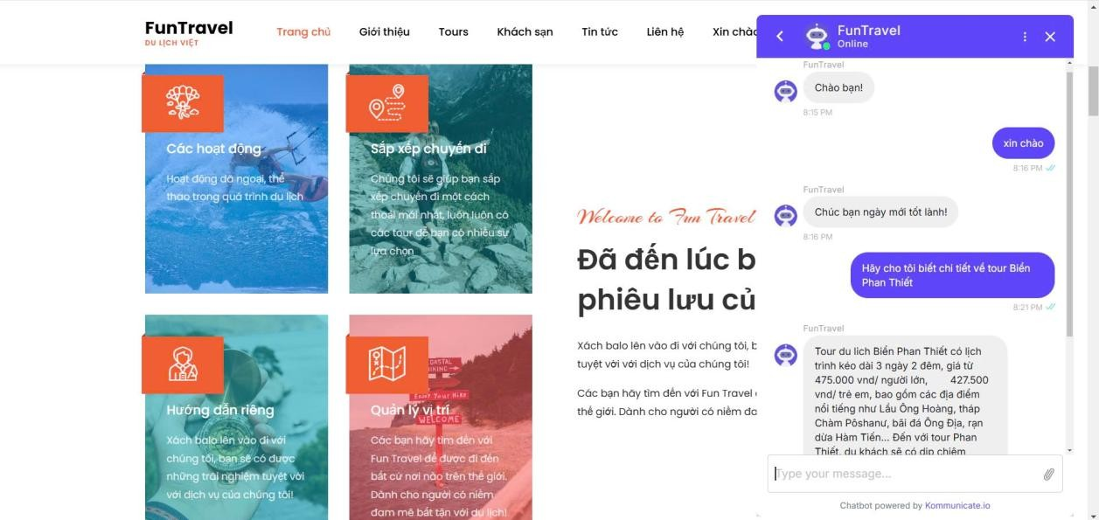
Figure 4.27: Chatbot AI

In addition to using chatbots to automatically answer questions, staff can chat directly with customers to advise them about tours in the most detail.
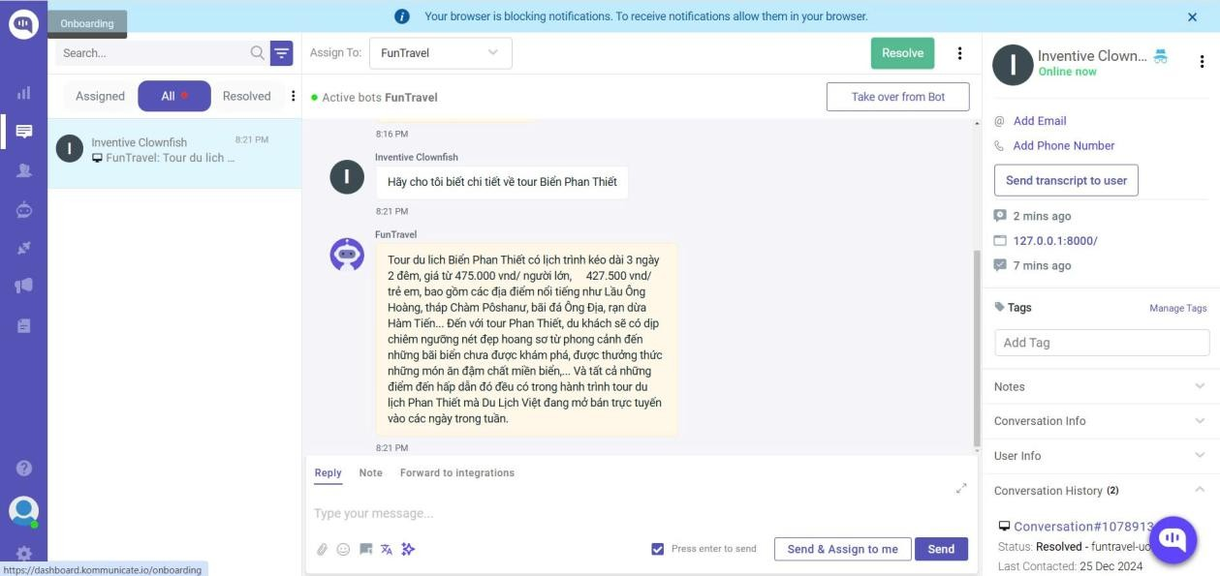
Figure 4.27: Chatbot AI

EVALUATION AND CONCLUSION

Evaluation
Building a tour booking website is not a novel concept but remains highly practical, especially in Vietnam's current phase of industrialization and modernization. Information technology is becoming increasingly essential for businesses, including tourism companies, making the development of dedicated websites a critical need. Guided by the suggestions of our advisor, Ms. Dương Thị Mai Nga, this project was implemented as a suitable management solution for tourism company websites.
The Fun Travel website is an example of effectively building and managing a tourism website to attract potential customers. However, due to time and resource limitations, the website developed in this project only meets basic requirements. Future enhancements will be necessary for real-world application.
Despite these limitations, the project successfully achieved the following:
- Interface: design based on available templates and operational options to enhance aesthetics and create vivid features, attracting viewers to drop the website.
- The entire website uses templates to design and install a browser on the template for the decentralized administration section.
- Programming to display Tour content, tourist attractions, areas, etc.
- The process allows customers to book Tours online on the website.
- The administrator allows adding, editing, deleting Tour programs or tourist attractions.
- Customer booking management
- Successfully uploading images or updating images in the management of tour programs and tourist attractions.
- All input data is deleted from the data fields
- Customer accounts have been automated
- Administrators are managed to assign the specified levels of authority (add, delete, edit administrators).

Development Directions
This project can be further developed in the following ways: User Interface Improvements:
Add and refine features to attract more customers, such as:
- News and Events: Provide updates on company activities and significant domestic and international tourism news.
- Services: the page presents other tourism services of the company or other partners of the company in the tourism field such as: entertainment services, additional services for tourists (renting cars, canoes, bicycles, motorbikes...) or a list of

information, addresses of hotels in each locality. On this page, it is possible to negotiate with these partners, hotels to collect advertising fees or exchange information of their websites to increase the opportunity to bring Fun Travel's website to an unlimited source of potential customers from the Internet.
- Other information: use separate service packages on the market to provide some other information for tourists: weather forecast information in some major tourist destinations in the country...
Add Website Management Features:
- Loyalty management: allows the company's customers to register for membership in the company's customer club and depending on the level of "loyalty" of the member to the company, the company will have appropriate incentives.
- Manage the company's promotional program with Tour programs organized at each time to promptly and accurately notify customers.
- When Vietnam has officially introduced online payment through a legal and highly secure authentication system, we will combine this payment solution for customers to book Tours, then the real e-commerce process can be carried out on this website.
- Enhance website security
- Server Security: use security modes on the server where the website is stored, can use HTTPS Server (HTTPS is Hypertext Transfer Protocol that uses security services, SSL Protocol provides encryption), to encrypt customer information, increase authentication and security for the website.
Securing website source code: can use techniques to encrypt the entire website source code to prevent theft and secure information

REFERENCES
[1]. PHP Documentation: https://www.php.net/manual/en/
[2]. Laravel Documentation: https://laravel.com/docs/11.x/readme
[3]. Dialogflow Documentation: https://cloud.google.com/dialogflow/docs [4]. StarUML Documentation: https://docs.staruml.io/
[5]. PHP Tutorial: https://www.phptutorial.net/

APPENDIX
List of Screens

No. | Screen Name | Display File and Link
1 | Homepage | http://127.0.0.1:8000/
2 | Tour Introduction Page | http://127.0.0.1:8000/ve-chung-toi.html
3 | Tour List Page | http://127.0.0.1:8000/tour.html
4 | Tour Details Page | http://127.0.0.1:8000/tour/{id}
5 | Hotel List Page | http://127.0.0.1:8000/khach-san.html
6 | Hotel Details Page | http://127.0.0.1:8000/khach-san/{id}
7 | Tourism News Page | http://127.0.0.1:8000/tin-tuc.html
8 | News Details Page | http://127.0.0.1:8000/tin-tuc/{id}
9 | Contact Us Page | http://127.0.0.1:8000/lien-he.html
10 | Account Registration Page | http://127.0.0.1:8000/dang-ky-tai-khoan.html
11 | Account Login Page | http://127.0.0.1:8000/dang-nhap.html
12 | Admin Dashboard | http://127.0.0.1:8000/admin/home
13 | Category Management Page | http://127.0.0.1:8000/public/admin/category
14 | Travel Articles Management  Page | http://127.0.0.1:8000/public/admin/article
15 | Travel Locations  Management Page | http://127.0.0.1:8000/public/admin/location
16 | Tour Management Page | http://127.0.0.1:8000/public/admin/tour
17 | Hotel Management Page | http://127.0.0.1:8000/public/admin/hotel
18 | Tour Booking List  Management Page | http://127.0.0.1:8000/public/admin/book-tour
19 | Comments Management  Page | http://127.0.0.1:8000/public/admin/comments
20 | User Role Management Page | http://127.0.0.1:8000/public/admin/role
21 | User Account Management  Page | http://127.0.0.1:8000/public/admin/user

